**HO CHI MINH UNIVERSITY OF TECHNOLOGY AND EDUCATION**

**FACULTY OF INTERNATIONAL EDUCATION**----------------------------



**CAPSTONE PROJECT**

**CREATING AN ONLINE MOVIE STREAMING WEB APPLICATION**

**Students:**

**Chu Nguyễn Hoàng Sơn 19119128**

**Nguyễn Quốc Hoàng 19110128**

**Instructor: PhD. Mai Anh Thơ**

Ho Chi Minh City, December 2024

|  |  |
| --- | --- |
|  | **SOCIALIST REPUBLIC OF VIETNAM**  **Independence - Freedom – Happiness**  **\*\*\*\*\*\*\*** |

*Ho Chi Minh City, December, 2024*

# CAPSTONE PROJECT OBJECTIVES

Students’ names:

1. Chu Nguyễn Hoàng Sơn ID: 19119128 Class: 19110CLA2

2. Nguyễn Quốc Hoàng ID: 19110128 Class: 19110CLA1

Major: **Information Technology**

Instructor: **PhD. Mai Anh Thơ**

Date of assignment: 02/09/2024 Date of submission: 12/12/2024

1. Project title: **Creating an online movie streaming web application**
2. Initial materials provided by supervisor: **None**
3. Content of the project:

Theory:

* Nextjs
* Nodejs
* Expressjs
* PostgreSQL
* Cloudinary

Practice:

Creating an online movie streaming web application with a recommender system are the main features:

* Enable website admins to oversee accounts, orders, products, and categories efficiently.
* Empower website admins to perform CRUD operations on product and category information.
* Enable website admins to review and modify order statuses for new orders.
* Provide customers with the ability to search and view product details.
* Allow customers to comment, rate on movies and complete orders with payment options (Paypal/ VNPay).
* Notify users about orders to help customers keep in track of their order process and to help the admin know customer's actions on order

1. Final product:

An web application combined with a recommender system

|  |  |
| --- | --- |
|  |  |
| **HEAD OF INFORMATION TECHNOLOGY PROGRAM**  *(Sign with full name)* | **INSTRUCTOR**  *(Sign with full name)* |

**Mai Anh Thơ**

|  |  |
| --- | --- |
|  | THE SOCIALIST REPUBLIC OF VIETNAM  **Independence – Freedom– Happiness**  *******  ---- |

# INSTRUCTOR’S EVALUATION SHEET

Students’ names:

1. Chu Nguyễn Hoàng Sơn ID: 19119128 Class: 19110CLA2

2. Nguyễn Quốc Hoàng ID: 19110128 Class: 19110CLA1

Major: **Information technology**

Project title: **Creating an online movie streaming web application**

Instructor: **PhD. Mai Anh Thơ**

EVALUATION:

1. Content of project:

1. Strengths:

1. Drawbacks:

1. Approval for oral defense? (Approved or denied)

5. Overall evaluation (Excellent, Good, Fair, Poor):

6. Mark: ……………......... (in words: ………………………..................................)

*Ho Chi Minh City, December, 2024*

**INSTRUCTOR**

*(Sign with full name)*

**Mai Anh Thơ**

|  |  |
| --- | --- |
|  | THE SOCIALIST REPUBLIC OF VIETNAM  **Independence – Freedom– Happiness**  *******  ---- |

# REVIEWER’S EVALUATION SHEET

Students’ names:

1. Chu Nguyễn Hoàng Sơn ID: 19119128 Class: 19110CLA2

2. Nguyễn Quốc Hoàng ID: 19110128 Class: 19110CLA1

Major: **Information technology**

Project title: **Creating an online movie streaming web application**

Reviewer: **MSc. Nguyễn Đức Khoan**

EVALUATION:

1. Content and workload of the project:

1. Strengths:

1. Drawbacks:

1. Approval for oral defense? (Approved or denied)

5. Overall evaluation (Excellent, Good, Fair, Poor):

6. Mark: ……………......... (in words: ………………………..................................)

*Ho Chi Minh City, December, 2023*

**REVIEWER**

*(Sign with full name)*

**Mai Anh Thơ**

# ACKNOWLEDGEMENTS

*We would like to express our appreciation to the instructor, PhD Mai Anh Tho, who worked closely with us to develop a project that enabled us to successfully finish our report. Throughout this course, you have constantly assisted us with our difficulties in the study process as well as provided us with excellent feedback and recommendations to help us grow as developers in the future. As a result, you have become our inspiration for this final project, and we would like to express our gratitude for the opportunity to learn from you on this course. Everyone on our team has various talents, and we have discovered our shortcomings in each other over this final assignment, but we've all managed to face this challenge as a team. As a result, everyone on our team is grateful for the opportunity to collaborate.*

*We now have all we need to learn about this subject and do well in it. Additionally, we want to thank our classmates for supplying us with a plethora of knowledge and pertinent facts that helped us to strengthen our thesis.*

*We finished the subject and report in a short measure of time, with restricted information and numerous different limitations regarding philosophies and skill with programming execution. As a consequence of this, there will undoubtedly be flaws in the process of creating the topic; consequently, we eagerly await your significant feedback so that we can increase the number of our experts and perform better the following time. This capstone project is the result of our tireless efforts throughout the semester. Because we are still novices, we are aware that our design has numerous shortcomings. We welcome any feedback as well as suggestions for improving our project. We appreciate it. Sincerely!*

*Ho Chi Minh City, December 2024*

*Chu Nguyễn Hoàng Sơn 19119128*

*Nguyễn Quốc Hoàng 19110128*

# TABLE OF CONTENTS

CAPSTONE PROJECT OBJECTIVES 2

INSTRUCTOR’S EVALUATION SHEET 4

REVIEWER’S EVALUATION SHEET 6

ACKNOWLEDGEMENTS 8

TABLE OF CONTENTS 1

LIST OF FIGURES 6

LIST OF TABLES 9

CHAPTER 1: INTRODUCTION 12

1.1. Reason for choosing the topic 12

1.2. Purpose of project 12

1.3. Object & scope 12

1.4. Expected results 13

CHAPTER 02: THEORY FUNDAMENTAL 14

2.1. System Architecture 14

2.2. Libraries 15

2.2.1. Front- End 15

2.2.2. Back- End 17

2.3. Technology 20

2.3.1. Reactjs 20

2.3.2. NextJS 22

2.3.3. NodeJS 24

2.3.4. ExpressJS 25

2.3.5. Cloudinary 27

2.3.6. PostgreSQL 30

CHAPTER 03: SURVEY AND SYSTEM REQUIREMENT 33

3.1. Surveys 33

3.1.1. General background 33

3.1.2. Surveys on popular movie streaming platforms 34

3.1.2.1. Netflix 34

3.1.2.2. Hulu 36

3.2. Functional requirements 38

3.2.1. Authorization 38

3.2.2. System’s Operations 38

3.3. Non-Functional requirements 39

3.4. Modeling requirements 40

CHAPTER 4: SYSTEM ANALYST AND DESIGN 42

4.1. USECASE DIAGRAMS 42

4.2. Usecase specification 43

4.2.1. Login 43

4.2.2. Register 44

4.2.3. Forgot password 45

4.2.4. Change profile information 47

4.2.5. Verify email 48

4.2.5. Add to favorite 49

4.2.6. Remove from favorite 50

4.2.7. Filter movies 51

4.2.8. View detail movie 52

4.2.9. Comment in detail movie 53

4.2.10. Edit comment in detail movie 54

4.2.11. Checkout VNPAY 55

4.2.12. Checkout PAYPAL 57

4.2.13. Create account 58

4.2.14. Disable account 59

4.2.15. Active account 60

4.2.16. Create subscription 61

4.2.17. Modify subscription 62

4.2.18. Delete subscription 64

4.2.19. Create movie 65

4.2.20. Modify movie 66

4.2.21. Create episode 67

4.2.22. Delete episode 68

4.2.23. Create category 69

4.2.24. Modify category 70

4.2.25. Delete category 72

4.2.26. Filter statistics 73

4.3. Sequence diagrams 75

4.3.1. Login 75

4.3.2. Register 76

4.3.3. Reset password 77

4.3.4. Change profile information 78

4.3.5. View movie information 79

4.3.6. View episode information 80

4.3.7. Filter movies 81

4.3.8. Favourite list management 82

4.3.9. Manage comment 83

4.3.10. Active email 84

4.3.11. Admin user management 85

4.3.12. Admin movie management 86

4.3.13. Admin episode management 87

4.3.14. Admin categories management 88

4.4. Class Diagram 89

4.5. Database 90

4.5.1. ERD 90

**4.5.2. Database table details** 91

**4.5.3.1. tbuserinfo table** 91

**4.5.2.2. tbcategoriesinfo table** 93

**4.5.2.3. tbemailverification table** 94

**4.5.2.4. tbfavouritelist table** 95

**4.5.2.5. tbloginhistory table** 96

**4.5.2.6. tbmoviecomment table** 97

**4.5.2.7. tbmovieepisode table** 98

**4.5.2.8. tbmovieinfo table** 99

**4.5.2.9. tborderhistory table** 101

**4.5.2.10. tbpasswordreset table** 103

**4.5.2.11. tbpaypalpayment table** 104

**4.5.2.12. tbsubcriptionplaninfo table** 105

**4.5.2.13. tbusersubscription table** 107

**4.5.2.14. tbvnpaypayment table** 107

**4.5.2.15. tbwatchhistory table** 109

4.6. Application interfaces 110

4.6.1. Guest 110

4.6.1.1. Register page 110

4.6.1.2. Reset password page 112

4.6.1.3. Login page 113

4.6.1.4. Policy page 114

4.6.2. Customer 115

4.6.2.1. Customer’s Homepage 115

4.6.2.2. Profile Page 118

4.6.2.3. Subscription Page 120

4.6.2.5. Order History Page 122

4.6.2.6. Categories Page 124

4.6.2.7. Movie Detail Page 125

4.6.2.8. Movie Episode Page 127

4.6.2.9. Favourite Page 129

4.6.3. Admin 130

4.6.3.1. Admin Page 130

4.6.3.2. Admin User Page 131

4.6.3.3. Admin Subscription Page 134

4.6.3.3. Admin Movie Page 139

4.6.3.4. Admin Movie Detail Page 142

4.6.3.5. Admin Categories Page 146

4.6.3.6. Admin Statistic Page 148

CHAPTER 05: IMPLEMENTATION AND TESTING 150

5.1. Implementation 150

5.1.1. Environment 150

5.1.2. Technology 152

5.1.3. Project file structure 153

5.1.3.1. Back-end file structure 153

5.1.3.2. Front-end file structure 156

5.2. Deploymentation 163

5.3. Testing 164

CHAPTER 06: CONCLUSION 166

6.1. Achievements 166

6.1.1. Knowledge and skills 166

6.1.2. Product 166

6.2. Strengths and drawbacks 167

6.2.1. Strengths 167

6.2.2. Drawbacks 168

6.3. Future improvement 168

REFERENCES 169

# LIST OF FIGURES

Figure 1. System Architecture 14

Figure 2: Reactjs 20

Figure 3: NextJS 22

Figure 4: NodeJS 24

Figure 5: ExpressJS 25

Figure 6: Cloudinary 27

Figure 7: PostgreSQL 30

Figure 8: Year of Movie Distribution by Platforms 34

Figure 9: Netflix website 34

Figure 10: Hulu website 36

Figure 11: System Diagram 42

Figure 12: Login sequence 75

Figure 13: Register sequence 76

Figure 14: Reset password sequence 77

Figure 15: Change profile information sequence 78

Figure 16: View movie information sequence 79

Figure 17: View episode information sequence 80

Figure 18: Filter movies sequence 81

Figure 19: Favourite list management sequence 82

Figure 20: Manage comment diagrams 83

Figure 21: Active email sequence 84

Figure 22: Admin user management sequence 85

Figure 23: Admin movie management 86

Figure 24: Admin episode management 87

Figure 25: Admin categories management sequence 88

*Figure 26: Class Diagram* 89

Figure 27: ERD 90

Figure 28: Register Page 110

Figure 29: Reset password page 112

Figure 30: Login Page 113

Figure 31. Policy Page 114

Figure 32: Customer's Homepage 115

Figure 33. Profile Page 118

Figure 34: Subscription Page 1 120

Figure 35: Subscription Page 2 120

Figure 36: Order History Page 122

Figure 37: Categories Page 124

Figure 38: Movie Detail Page 125

Figure 39: Movie Detail Page 127

Figure 40: Favourite Page 129

Figure 41: Admin Page 130

Figure 42: Admin User Page 131

Figure 43: User Detail Panel 131

Figure 44: Admin Subscription Page 134

Figure 45: Subscription Detail Panel 135

Figure 46: Admin Movie Page 139

Figure 47: Admin Movie Detail Page 142

Figure 48: Admin Episode Detail Panel 142

Figure 49: Admin Add Episode Panel 143

Figure 50: Admin Categories Page 146

Figure 51: Admin Category Detail Panel 146

Figure 52: Admin Statistic Page 148

Figure 53: PostgreSQL Database 150

Figure 54: Supabase Service 151

Figure 55. Cloudinary 151

Figure 56: Code Environment 152

Figure 57: ReactJS & NextJS 152

Figure 58: NodeJS & ExpressJS 153

Figure 59. Back-end file structure 155

Figure 60: Front-end file structure 163

# LIST OF TABLES

*Table 1. Front-End Libraries 15*

*Table 2. Back-End Libraries 17*

*Table 3. Advantages and Disadvantages of Netflix 35*

*Table 4. Advantages and Disadvantages of Hulu 37*

*Table 5. Authorization 38*

*Table 6. System's Operations 38*

*Table 7. Modeling requirement 40*

*Table 8: Login use case specification 43*

*Table 9: Register use case specification 44*

*Table 10: Forgot password use case specification 45*

*Table 11: Change profile use case specification 47*

*Table 12: Change profile use case specification 48*

*Table 13: Add to favorite use case specification 49*

*Table 14: Remove from favorite use case specification 50*

*Table 15: Filter movies use case specification 51*

*Table 16: View detail movie use case specification 52*

*Table 17: Comment in detail movie use case specification 53*

*Table 18: Comment in detail movie use case specification 54*

*Table 19: Checkout VNPAY use case specification 55*

*Table 20: Checkout PAYPAL use case specification 57*

*Table 21: Create account use case specification 58*

*Table 22: Disable account use case specification 59*

*Table 23: Active account use case specification 60*

*Table 24: Create subscription use case specification 61*

*Table 25: Modify subscription use case specification 62*

*Table 26: Delete subscription use case specification 64*

*Table 27: Create movie use case specification 65*

*Table 28: Modify movie use case specification 66*

*Table 29: Create episode use case specification 67*

*Table 30: Delete episode use case specification 68*

*Table 31: Create category use case specification 69*

*Table 32: Modify category use case specification 70*

*Table 33: Delete category use case specification 72*

*Table 34: Filter statistics use case specification 73*

*Table 35: tbuserinfo table 92*

*Table 36: tbcategoriesinfo table 93*

*Table 37: tbemailverification table 94*

*Table 38: tbfavouritelist table 95*

*Table 39: tbloginhistory table 96*

*Table 40: tbmoviecomment table 97*

*Table 41: tbmovieepisode table 98*

*Table 42: tbmovieinfo table 100*

*Table 43: tborderhistory table 102*

*Table 44: tbpasswordreset table 103*

*Table 45: tbpaypalpayment table 104*

*Table 46: tbsubcriptionplaninfo table 106*

*Table 47: tbusersubscription table 107*

*Table 48: tbvnpaypayment table 108*

*Table 49: tbwatchhistory table 109*

*Table 50: Register Page Object 110*

*Table 51: Reset Password Page Object 112*

*Table 52. Login Page Object 113*

*Table 53. Policy Page Objects 114*

*Table 54: Customer's Homepage Object 116*

*Table 55: Profile Page Object 118*

*Table 56: Subscription Page Object 121*

*Table 57: Order History Page Objects 122*

*Table 58: Categories Page Objects 124*

*Table 59: Movie Detail Page Objects 126*

*Table 60: Movie Episode Page Objects 127*

*Table 61: Favourite Page Objects 129*

*Table 62: Admin Page Objects 130*

*Table 63: Admin User Page Objects 132*

*Table 64: Admin Subscription Page 135*

*Table 65. Admin Movie Page 139*

*Table 66: Admin Movie Detail Page 143*

*Table 67: Admin Categories Page Objects 147*

*Table 68: Admin Statistic Page Objects 149*

*Table 69. Production test accounts 163*

*Table 70. Testcases 164*

# CHAPTER 1: INTRODUCTION

## 1.1. Reason for choosing the topic

More and more people enjoy watching movies online to relax instead of going outside nowadays, the idea of a movie watching and streaming application has become an interesting topic to develop. We are looking to create something for entertainment but still convenient.

Building a movie watching and streaming website for users lets you share a wide range of movies with others, without needing a physical space like a movie theater but still be able to spend time with friends and family.

It's a simple and modern way for people to enjoy films right from their devices, making it easy to watch anytime, anywhere.

## 1.2. Purpose of project

Provide users with convenient and instant access to a vast library of movies from various genres, languages, and time periods.

The application aims to deliver an enjoyable, personalized viewing experience by offering a user-friendly platform.

They can explore, discover, and watch films of their choice at any time, from anywhere.

## 1.3. Object & scope

***Product scope:***

* Product Goal: Build an online movie streaming platform similar to major platforms, providing an optimal user experience with rich content and ease of use.
* Core Functions: Focus on streaming, account management, payment processing, and copyright protection.
* Target Users: Movie watchers with internet access, using multiple platforms from mobile, desktop, to smart TV.
* Development Direction: Create a diverse content library, integrate AI to suggest content based on user preferences, expand payment options, and support multiple device formats.

***Project scope:***

* Platform Development: Design and implement the backend (server, database) and frontend (user interface).
* Service Integration: Connect with payment services, security (DRM), and data analytics.
* Testing and Quality Assurance: Perform functional, security, and performance testing on different devices.
* Project Management: Plan the deployment in phases (MVP, additional feature development), manage the development team, and track progress.
* Support and Maintenance: Update the platform, provide technical support for users, and monitor the system to ensure continuous operation.

## 1.4. Expected results

The anticipated outcomes include the creation of a dynamic online movie platform where users experience seamless interactions, such as browsing, watching, commenting, and rating movies. With the integration of a robust recommendation system, personalized movie suggestions based on user preferences are expected to enhance user engagement and satisfaction. Streamlined features for administrators ensure efficient management of movie libraries, user accounts, and content moderation. This user-friendly platform aims to deliver an enjoyable, accessible experience tailored to movie enthusiasts on desktop devices.

# CHAPTER 02: THEORY FUNDAMENTAL

## 2.1. System Architecture

In our front-end development, we utilize ReactJS with NextJS framework. At back-end, we harness the capabilities of NodeJS for API development. Our database solution is powered by PostgreSQL. The overall system architecture adheres to the Client-Server Model, strategically capitalizing on the inherent flexibility and performance benefits offered by these seamlessly integrated technologies.

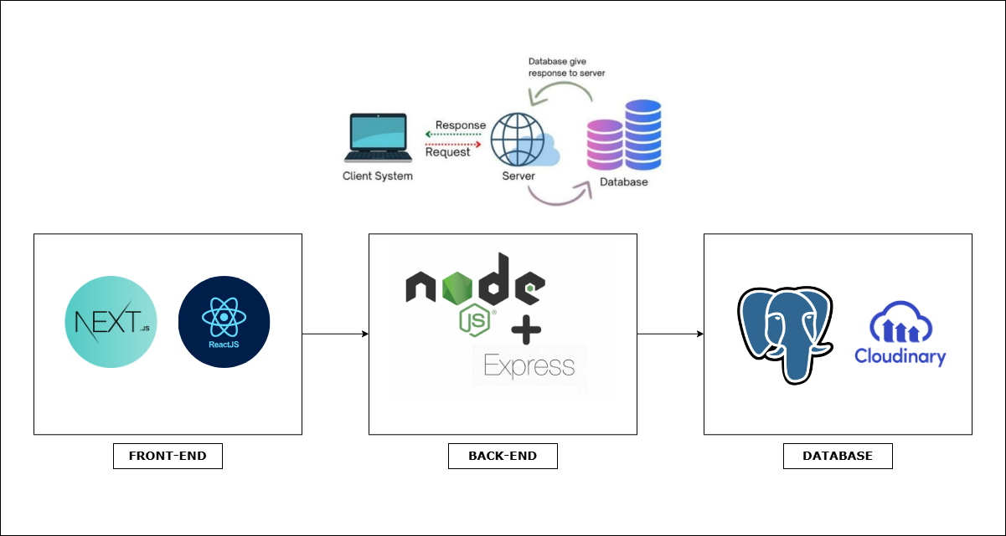

Figure . System Architecture

## 2.2. Libraries

### 2.2.1. Front- End

Table . Front-End Libraries

|  |  |  |
| --- | --- | --- |
| **Library** | **Version** | **Description** |
| nextui-org/* | 2.x.x | A set of React components designed for building user interfaces with ease, part of the NextUI framework. |
| paypal/react-paypal-js | 8.7.0 | A React wrapper for integrating PayPal buttons and other functionalities. |
| radix-ui/react-slider | 1.2.1 | A customizable slider component for React apps. |
| react-aria/ssr | 3.9.4 | Tools for handling server-side rendering accessibility issues. |
| react-aria/visually-hidden | 3.8.12 | A utility for visually hidden elements (like screen-reader text). |
| tabler/icons-react | 3.22.0 | Icon components for React, based on Tabler's icon library. |
| canvas-confetti | 1.9.3 | A lightweight library to create confetti effects on a web canvas. |
| cloudinary | 2.5.1 | A library for managing image and video uploads and transformations via the Cloudinary API. |
| clsx | 2.1.1 | A utility for dynamically combining class names based on conditions. |
| embla-carousel-autoplay | 8.3.0 | A lightweight, customizable carousel slider library for React. |
| embla-carousel-react | 8.3.0 | A plugin for Embla Carousel that enables autoplay functionality. |
| framer-motion | 11.1.1 | A powerful animation library for React, useful for creating fluid and interactive UI animations. |
| glob | 11.0.0 | A utility to find files/directories using patterns (useful for working with file systems). |
| intl-messageformat | 10.5.0 | A library for formatting messages for internationalization |
| moment | 2.30.1 | A popular library for parsing, manipulating, and formatting dates and times. |
| next | 14.2.13 | The core Next.js library for building React-based web applications with server-side rendering and static site generation. |
| next-auth | 4.24.8 | An authentication library for Next.js supporting various providers (e.g., Google, GitHub, etc.). |
| next-cloudinary | 6.16.0 | A Next.js-specific Cloudinary utility for managing media in your app. |
| next-themes | 0.2.1 | A theme management library for handling light/dark mode in Next.js. |
| react | 18.3.1 | The core libraries for building React applications. |
| react-dom | 18.3.1 | The core libraries for building React applications |
| react-simple-star-rating | 5.1.7 | A simple star rating component for React apps. |
| react-toastify | 10.0.6 | A library for showing toast notifications in React apps. |
| rimraf | 6.0.1 | A utility for deleting files and directories (a cross-platform alternative to rm -rf). |
| tailwindcss | 3.4.3 | A utility-first CSS framework for creating custom designs efficiently. |
| typescript | 5.0.4 | A superset of JavaScript that adds static typing, helping catch errors early during development. |
| eslint | 8.57.0 | A linting tool to ensure consistent code style and catch common coding errors. |

### 2.2.2. Back- End

Table . Back-End Libraries

|  |  |  |
| --- | --- | --- |
| **Library** | **Version** | **Description** |
| bcryptjs | 2.4.3 | A library for hashing passwords. It is used to securely store and verify user passwords. |
| cloudinary | 2.5.1 | Provides integration with the Cloudinary API to handle image and video uploads, storage, and transformations. |
| cookie-parser | 1.4.7 | Middleware for parsing cookies in HTTP requests. |
| cors | 2.8.5 | Middleware for enabling Cross-Origin Resource Sharing, allowing your server to handle requests from different origins. |
| cross-env | 7.0.3 | Allows you to set environment variables across different operating systems in a consistent way. |
| express | 4.21.0 | A popular web framework for Node.js, used to create APIs and handle HTTP requests and responses. |
| google-auth-library | 9.14.2 | A library for implementing Google authentication and working with Google APIs. |
| googleapis | 144.0.0 | Provides access to Google's APIs, such as Drive, Sheets, and Calendar. |
| jsonwebtoken | 9.0.2 | A library for generating and verifying JSON Web Tokens (JWTs), commonly used for authentication and secure data transfer. |
| moment | 2.29.4 | A library for manipulating and formatting dates and times. |
| moment-timezone | 0.5.46 | An extension of Moment.js for handling time zones. |
| multer | 1.4.5-lts.1 | A middleware for handling multipart/form-data, commonly used for uploading files. |
| nodemailer | 6.9.15 | A library for sending emails through Node.js. |
| pg | 8.13.0 | A library for interfacing with PostgreSQL databases, allowing you to query and manage the database. |
| ws | 8.18.0 | A WebSocket library for enabling real-time communication between the server and clients. |
| eslint | 8.24.0 | A tool to identify and fix coding issues, ensuring a consistent code style. |
| nodemon | 3.1.7 | A utility that automatically restarts your server when it detects file changes, streamlining the development process |

## 2.3. Technology

### 2.3.1. Reactjs



Figure : Reactjs

**What is Reactjs?**

React.js is an open-source JavaScript library for building user interfaces. Developed by Facebook, it's widely used for creating dynamic and efficient web applications. React.js employs a component-based architecture, allowing developers to build UIs as a collection of reusable and modular components. It utilizes a virtual DOM, enhancing performance by minimizing actual DOM manipulations. React.js supports a unidirectional data flow, making it easier to manage and update state changes. Its declarative syntax simplifies the creation of complex UIs, promoting code readability and maintainability. React.js is often used in conjunction with other libraries or frameworks and is known for its efficiency in handling real-time updates and rendering large datasets.

**Why use Reactjs?**

* Component-Based Architecture: React.js promotes code reusability and maintainability through a component-based approach, where UIs are built as a collection of modular components.
* Virtual DOM Efficiency: React's use of a virtual DOM minimizes actual DOM manipulations, ensuring efficient updates and optimizing overall performance.
* Declarative Syntax: The declarative nature of React simplifies the development of complex UIs, making code more readable and easier to understand.
* Unidirectional Data Flow: React supports unidirectional data flow, facilitating the management of state changes and enhancing predictability in application behavior.
* Community and Ecosystem: The strong community and extensive ecosystem surrounding React provide ample support, libraries, and tools for developers, contributing to the framework's robustness.
* Popularity and Adoption: React's widespread adoption by major companies ensures long-term viability and continuous improvement, making it a reliable choice for web application development.

**How to apply Reactjs to build our project?**

In our project, ReactJS is fundamental for front-end development, enabling a dynamic user interface.

* Front-end Construction: React's component-based architecture streamlines code organization, ensuring a maintainable codebase.
* Event Handling: React facilitates seamless responses to user interactions through functions responding to events like clicks or input changes.
* Route Management: Incorporating React Router enhances navigation, ensuring intuitive updates based on URL changes.
* API Interaction: React facilitates efficient data communication with the backend through technologies like Fetch API or Axios.

In conclusion, our strategy maximizes ReactJS, empowering the creation of a robust, interactive web application with a responsive UI, effective event handling, streamlined navigation, and seamless API interactions.

### 2.3.2. NextJS



Figure : NextJS

**What is NextJS?**

Next.js is a powerful open-source React framework designed for building fast, scalable, and SEO-friendly web applications. It simplifies web development by offering features like server-side rendering (SSR), static site generation (SSG), and API routes out of the box. With Next.js, developers can create dynamic and optimized websites that provide an excellent user experience. Its developer-friendly structure and robust community support make it a popular choice for modern web development.

**Why use NextJS?**

* Server-Side Rendering (SSR): Next.js allows rendering pages on the server, improving performance and ensuring content is SEO-friendly. This is especially useful for content-heavy or dynamic applications.
* Static Site Generation (SSG): With SSG, pages can be pre-rendered at build time, making them load faster and reducing server overhead.
* API Routes: Next.js enables creating backend API endpoints directly in the project, eliminating the need for a separate server.
* Routing Made Simple: The file-based routing system automatically generates routes based on the folder structure, simplifying navigation and reducing setup time.
* Performance Optimization: Built-in features like image optimization, code splitting, and automatic bundling ensure fast-loading and efficient applications.
* Flexibility: Developers can choose between SSR, SSG, or client-side rendering (CSR) for different parts of the application, adapting to specific project requirements.
* Built-in CSS and Sass Support: Next.js supports CSS modules and preprocessors like Sass, allowing for modular and maintainable styling.
* TypeScript Support: Seamless integration with TypeScript ensures type safety and better maintainability.
* Community and Ecosystem: As part of the React ecosystem, Next.js benefits from an active community, extensive documentation, and numerous third-party plugins.
* Open Source: Next.js is open source, making it freely available for developers to use, modify, and collaborate.

**How to apply NextJS to build our project?**

Next.js plays a pivotal role in streamlining the process of building modern web applications. Its powerful features, such as server-side rendering (SSR), static site generation (SSG), and dynamic routing, simplify the creation of performant, scalable, and SEO-friendly applications. With Next.js, developers can efficiently structure their projects, optimize page loading, and enhance user experience without the complexity of managing separate tools or configurations. By providing a unified framework, Next.js reduces development time while ensuring flexibility and maintainability in building robust web applications..

### 2.3.3. NodeJS



Figure : NodeJS

**What is NodeJS?**

Node.js is an open-source, cross-platform runtime environment for executing JavaScript code on the server side. Built on Chrome's V8 JavaScript engine, Node.js is designed to build scalable network applications. Its event-driven, non-blocking I/O model ensures high performance and makes it ideal for building real-time, data-intensive applications.

**Why use NodeJS?**

* High Performance: Node.js is built on the V8 engine, offering fast execution and high performance for server-side applications.
* Asynchronous and Event-Driven: The non-blocking I/O model enables handling multiple requests simultaneously, making it suitable for real-time applications.
* JavaScript Everywhere: With Node.js, developers can use JavaScript for both client-side and server-side, unifying the development stack.
* Scalability: Its lightweight architecture and support for microservices allow building scalable applications.
* Rich Ecosystem: The npm (Node Package Manager) provides access to thousands of open-source libraries, accelerating development.
* Real-Time Capabilities: Node.js excels in building real-time applications like chat apps and collaborative tools using WebSockets.
* API Development: Node.js simplifies the creation of RESTful APIs, allowing seamless integration with frontend frameworks.
* Cross-Platform Support: Developers can use Node.js to build applications that run on multiple platforms, including Windows, macOS, and Linux.
* Community and Support: Node.js has an extensive and active community that provides plugins, tools, and documentation.
* Open Source: Node.js is freely available, fostering collaboration and innovation within the developer community.

**How to apply NodeJS to build our project?**

Node.js is an open-source runtime environment for executing JavaScript on the server side. Built on Chrome's V8 engine, it is ideal for creating scalable, real-time, and data-intensive applications with its event-driven, non-blocking I/O model.

How to Use Node.js in a Project:

* Building APIs: Develop robust RESTful APIs using frameworks like Express.js for efficient routing and middleware management.
* Database Connectivity: Connect to databases like MongoDB or PostgreSQL with libraries like Mongoose or Sequelize for seamless data handling.
* Security with JWT: Secure APIs with JSON Web Token (JWT) authentication, ensuring safe user access.

### 2.3.4. ExpressJS



Figure : ExpressJS

**What is ExpressJS?**

Express.js is a minimal, flexible, and powerful web application framework for Node.js. It provides a robust set of features for building web applications and APIs. By simplifying the process of handling HTTP requests, routing, and middleware, Express.js allows developers to create scalable and efficient server-side applications with ease.

**Why use ExpressJS?**

* Simplified Server Setup: Express.js abstracts the complexities of Node.js and provides an intuitive way to set up a server.
* Routing Made Easy: It offers a simple and powerful routing mechanism to define and handle different endpoints in your application.
* Middleware Support: Express.js supports middleware, enabling efficient request processing, authentication, logging, and error handling.
* Scalability: Its modular structure makes it suitable for building small applications and scaling them into complex systems.
* Integration with Databases: Express.js integrates seamlessly with databases like MongoDB, PostgreSQL, and PostgreSQL, providing flexibility for back-end development.
* Extensive Community and Ecosystem: With a rich ecosystem of plugins and tools, developers can extend Express.js functionality to meet project requirements.
* Lightweight: Its minimalist design ensures high performance and low overhead, making it ideal for real-time applications and APIs.
* Compatible with Front-End Frameworks: Express.js works seamlessly with modern front-end libraries and frameworks like React, Angular, and Vue.js.
* Customizability: Developers can customize every aspect of the application to suit their needs without being restricted by rigid conventions.
* Open Source: As an open-source framework, Express.js is free and backed by a vibrant community.

### 2.3.5. Cloudinary



Figure : Cloudinary

**What is Cloudinary?**

Cloudinary is a cloud-based media management platform that provides storage, optimization, and delivery services for images and videos. It allows developers to upload, store, manage, transform, and deliver media content seamlessly using advanced cloud computing features. Cloudinary is widely used by developers and businesses for media hosting, real-time optimization, and fast delivery via Content Delivery Networks (CDNs).

Key features of Cloudinary include:

* Cloud-based storage for media assets (images, videos, audio, etc.).
* Media transformation (resize, crop, compress, and edit images and videos dynamically).
* Adaptive bitrate streaming for optimal video playback across different devices and network conditions.
* CDN-powered delivery for faster content access globally.
* Security features, including access control, encryption, and authentication.
* Analytics tools to monitor media usage and optimize performance.

**Why use Cloudinary?**

Cloudinary offers several compelling advantages that make it ideal for online media hosting and delivery, especially for an online movie streaming website:

* Efficient Video Storage & Delivery: Cloudinary provides scalable cloud storage for large video files, ensuring videos can be securely stored and accessed without impacting server performance.
* Optimized Streaming: With adaptive bitrate streaming, Cloudinary adjusts video quality in real-time based on a user’s network speed and device type, minimizing buffering and improving user experience.
* Faster Loading Times: Cloudinary uses a global Content Delivery Network (CDN) to cache and deliver media content closer to users' locations, ensuring faster and smoother streaming experiences.
* Media Compression & Transformation: Videos and images can be resized, transcoded, and compressed on the fly without manual intervention, reducing file sizes while maintaining quality and performance.
* Ease of Integration: Cloudinary provides APIs and SDKs for most popular programming languages and frameworks, making integration straightforward for developers.
* Scalability: Cloudinary is built for scalability, allowing businesses to scale their media storage and delivery infrastructure as user demand increases.
* Secure Media Hosting: Cloudinary offers encryption, access control, and secure media access, ensuring that user-generated or proprietary media is protected.

**How to apply Cloudinary to build our project?**

To implement Cloudinary for an online movie streaming website, we would utilize its cloud-based media management capabilities to store, manage, and deliver streaming video content efficiently. Cloudinary provides secure, scalable, and optimized media storage solutions, allowing the website to store a vast catalog of videos, trailers, and other streaming content.

Using Cloudinary's advanced features, such as adaptive bitrate streaming, video compression, and CDN-powered delivery, we can ensure seamless playback experiences for users across different devices and network conditions. Cloudinary's cloud storage capabilities handle large video files, ensuring reliability and scalability as the movie streaming library expands. Its integration allows for faster delivery of video content by utilizing a global CDN, ensuring minimal buffering for users regardless of their location.

Integrating Cloudinary into the online movie streaming website provides a powerful, secure, and structured video hosting solution. This ensures that users can stream movies, TV shows, and other multimedia content without interruptions, with optimized video performance, reduced load times, and reliable playback quality. Cloudinary's analytics also allow website administrators to track usage patterns and make data-driven decisions to further optimize the user experience.

### 2.3.6. PostgreSQL



Figure : PostgreSQL

**What is PostgreSQL?**

PostgreSQL is a powerful, advanced, and widely used open-source relational database management system (RDBMS). It is known for its stability, scalability, and robustness, making it an ideal choice for businesses of all sizes. PostgreSQL is developed and supported by a global community of developers and offers comprehensive SQL compliance along with advanced features:

* PostgreSQL is a database management system.
* PostgreSQL databases are relational.
* PostgreSQL is Open Source and free to use.
* The PostgreSQL Database Server is fast, reliable, scalable, and easy to integrate.
* PostgreSQL supports advanced data types and indexing mechanisms.
* It works across multiple platforms, supporting both client-server architecture and embedded systems.
* A variety of contributed tools and extensions are available for PostgreSQL.

**Why use PostgreSQL?**

PostgreSQL is one of the most popular choices for database management for many compelling reasons:

* PostgreSQL is free and distributed under an open-source license, meaning it can be used without licensing costs.
* PostgreSQL supports advanced SQL features that make it a powerful database tool for complex queries.
* PostgreSQL uses standards-compliant SQL, making it an effective and versatile database for modern development.
* It integrates seamlessly with programming languages such as Python, Java, C++, PHP, Ruby, and more.
* PostgreSQL is highly efficient when working with large and complex datasets.
* It has strong support for advanced data types like JSON, XML, spatial data, arrays, and user-defined types.
* PostgreSQL scales well even when managing databases with millions of rows, and it supports advanced indexing options for better query performance.
* PostgreSQL's extensibility allows users to add custom features, operators, or data types to the system as required.

**How to apply PostgreSQL to build our project?**

To implement PostgreSQL for an online movie streaming website, we would design a relational database schema to store vital business information such as movie details, user accounts, subscriptions, viewing history, and payment transactions. PostgreSQL tables would include entities such as movies, genres, users, subscriptions, watchlists, viewing history, and payment information.

Using PostgreSQL's advanced querying features, we can effectively and efficiently retrieve and manipulate data to ensure seamless and fast user experiences on the streaming platform. Its ability to maintain data integrity through ACID compliance ensures that user accounts, subscription plans, payment transactions, and user viewing activity are always accurate and consistent. Additionally, PostgreSQL’s scalability allows it to handle a growing number of users and an expanding catalog of movies.

Integrating PostgreSQL with the online movie streaming website provides a robust, secure, and structured backend system. This ensures user data is well-organized, accessible, and manageable, delivering a strong foundation for building features such as personalized recommendations, user profiles, seamless payment options, and a reliable streaming experience.

# CHAPTER 03: SURVEY AND SYSTEM REQUIREMENT

## 3.1. Surveys

### 3.1.1. General background

* The past decade has witnessed a remarkable surge in the popularity of online movie streaming platforms. This shift in consumer behavior is evident in the increasing number of movies distributed by platforms like Netflix, Hulu, Prime Video, and Disney+. The convenience, affordability, and vast content libraries offered by these platforms have made them the preferred choice for many viewers.
* The growing demand for on-demand content has compelled traditional media companies to adapt to the evolving landscape and invest in their own streaming services. This has led to a proliferation of platforms, each offering unique content libraries and features to cater to diverse viewer preferences.
* The growth of online movie streaming platforms has also had a profound impact on the film industry. With a growing number of platforms competing for viewers' attention, there has been an increased emphasis on producing original content. This has created new opportunities for filmmakers and content creators, allowing them to reach wider audiences and experiment with innovative storytelling formats. Additionally, the rise of streaming platforms has led to a shift in the traditional theatrical release model, with some films being released simultaneously on streaming services and in theaters.
* As technology continues to advance, we can expect further innovation and growth in the realm of online movie streaming, offering viewers an even wider range of content and viewing experiences.

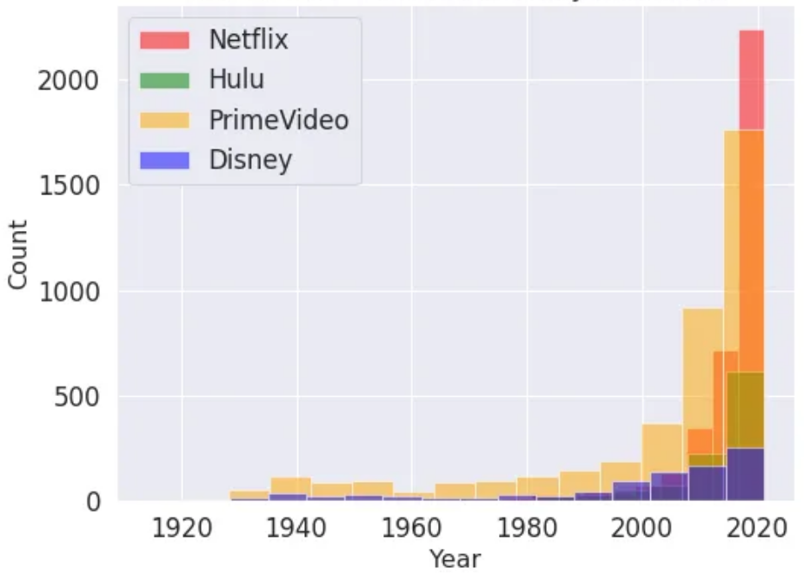

Figure : Year of Movie Distribution by Platforms

### 3.1.2. Surveys on popular movie streaming platforms

#### 3.1.2.1. Netflix

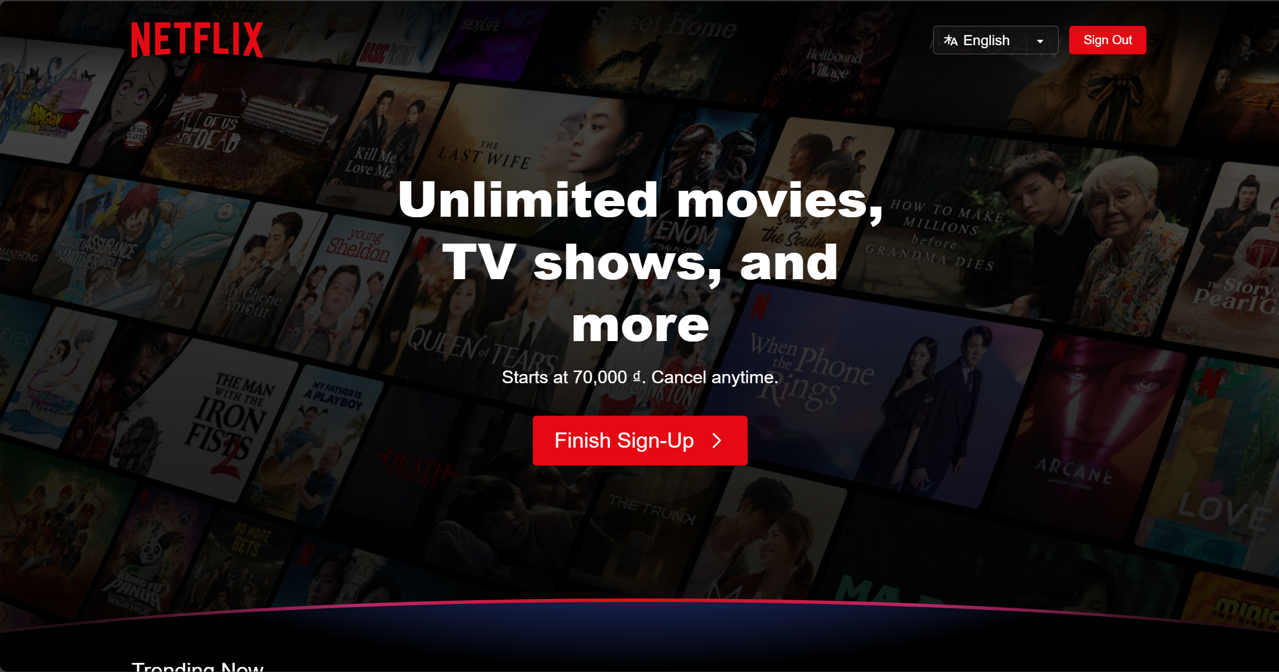

Figure : Netflix website

Table . Advantages and Disadvantages of Netflix

|  |  |
| --- | --- |
| **Advantages and Disadvantages of Netflix** | |
| Advantages | * Users can watch content anytime and anywhere, as long as they have an internet connection and a compatible device. * Netflix's intuitive interface makes it easy to browse and discover new shows and movies. * The algorithm suggests content based on viewing habits, helping users find shows and movies that match their tastes. * Users can create individual profiles under one account, ensuring personalized recommendations and watchlists for family members. * Allows users to download content for offline viewing, which is particularly helpful during travel or in areas with poor connectivity. * No interruptions from advertisements, providing a seamless entertainment experience. * Features like Kids' Profiles and maturity level filters ensure a safe viewing experience for children. * Access to diverse content from different cultures and languages, broadening entertainment options. |
| Disadvantages | * Users can watch content anytime and anywhere, as long as they have an internet connection and a compatible device. * Netflix's intuitive interface makes it easy to browse and discover new shows and movies. * The algorithm suggests content based on viewing habits, helping users find shows and movies that match their tastes. * Users can create individual profiles under one account, ensuring personalized recommendations and watchlists for family members. * Allows users to download content for offline viewing, which is particularly helpful during travel or in areas with poor connectivity. * No interruptions from advertisements, providing a seamless entertainment experience. * Features like Kids' Profiles and maturity level filters ensure a safe viewing experience for children. * Access to diverse content from different cultures and languages, broadening entertainment options. |

#### 3.1.2.2. Hulu



Figure : Hulu website

Table . Advantages and Disadvantages of Hulu

|  |  |
| --- | --- |
| **Advantages and Disadvantages of Hulu** | |
| Advantages | * Hulu provides budget-friendly plans, including an ad-supported tier, making it accessible to more users. * The Hulu + Live TV option lets users stream live sports, news, and other programming, combining traditional TV with streaming. * Hulu features exclusive shows like The Handmaid’s Tale and Only Murders in the Building, as well as licensed content from major networks. * Allows up to six profiles per account, ensuring tailored recommendations and watchlists for different users. * Offers Kids Profiles, filtering content to be age-appropriate for younger viewers. * Content can be downloaded on mobile devices for offline streaming, handy for travel or areas with poor internet connectivity. * Hulu offers bundles with Disney+ and ESPN+ at a discounted rate, providing diverse entertainment options. |
| Disadvantages | * Subscription fees may rise over time, and premium plans can be costly, especially for families needing multiple simultaneous streams. * Shows and movies can be removed from the platform due to licensing agreements, disappointing users who might not have finished watching. * Requires a stable and high-speed internet connection for smooth streaming, which can be a limitation in some areas. * With recent efforts to limit account sharing, users might face restrictions if they share their subscription with others. * The extensive library can lead to indecision, making it hard to settle on something to watch. * Content availability varies by location due to licensing restrictions, which might frustrate users looking for specific titles. * Binge-watching culture can lead to excessive screen time, impacting health and productivity. * Not all content is of high quality; some Netflix Originals receive criticism for being mediocre or rushed. |

## 3.2. Functional requirements

### 3.2.1. Authorization

Table . Authorization

|  |  |  |
| --- | --- | --- |
| **No.** | **Actor** | **Description** |
| 1 | Guest | Users do not have any account. |
| 2 | Customer | Users have already had a customer account on this application. |
| 3 | Admin | Users have already had an admin account on this application. |

### 3.2.2. System’s Operations

Table . System's Operations

|  |  |  |
| --- | --- | --- |
| **No.** | **Function** | **Description** |
| 1 | Register/Login | Customers create a new account/ login to website and application. |
| 2 | Forgot Password | Customers forgot password and can reset password with email. |
| 3 | Edit profile | Customers can edit their profile information |
| 4 | Active email | Customers can active their email |
| 5 | View account information | Customers can view their account information |
| 6 | View movie list | Customers can view movie list |
| 7 | View subscription plans | Customers can view subscription plans |
| 8 | Pay with VNPay, PayPal | Customers can pay with VNPay or PayPal |
| 9 | View transaction history | Customers can view their transaction history |
| 10 | View policy | Customers can view policy |
| 11 | Watch movie | Customers can watch movie |
| 12 | Comment and rating | Customers can comment and rating |
| 13 | Filter movie | Customers can filter movie |
| 14 | Manage favourite list | Customers can manage favourite list |
| 15 | Manage user account | Admin can manage user account |
| 16 | Manage movies | Admin can manage movies |
| 17 | Manage episodes | Admin can manage episodes |
| 18 | Manage categories | Admin can manage categories |
| 19 | Manage subscriptions | Admin can manage subscriptions |
| 20 | View statistics | Admin can view website statistics |

## 3.3. Non-Functional requirements

* User-friendly interface for easy navigation.
* Swift data processing to ensure efficient system performance.
* Strong security measures to protect customer's personal information.
* Easy updates and future expansions through a user-friendly system.
* Maintain data integrity to ensure customer trust and satisfaction.

## 3.4. Modeling requirements

Table . Modeling requirement

|  |  |
| --- | --- |
| **Actor** | **Requirement** |
| Guest | * Login * Register * View policy |
| Customer | * Log in/out * Register * Edit profile * Reset password with email * Active email * View movie list * View subscription plans * Pay with VNPay, PayPal * View transaction history * View policy * View account info * Watch movie * Comment and rating * Filter movie * Manage favourite list |
| Admin | * Manage user’s account * Manage movies * Manage episodes * Manage categories * Manage subscriptions * View statistic |

# CHAPTER 4: SYSTEM ANALYST AND DESIGN

## 4.1. USECASE DIAGRAMS

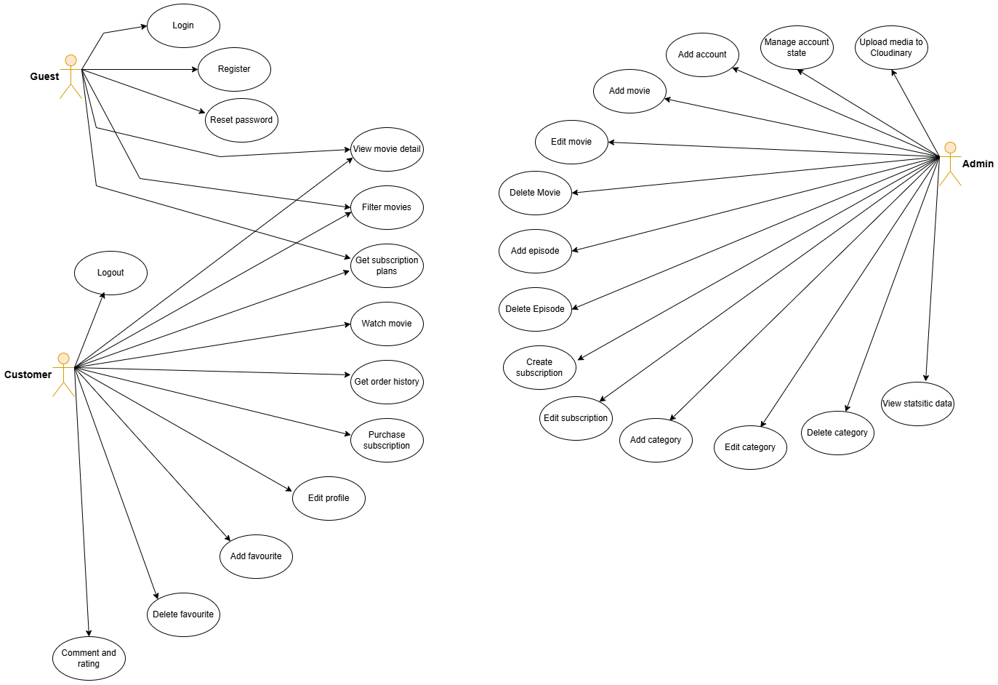

Figure : System Diagram

## 4.2. Usecase specification

### 4.2.1. Login

*Table 8: Login use case specification*

|  |  |
| --- | --- |
| **Name** | Log In |
| **Brief Description** | The way user website logins |
| **Actor(s)** | All user login into system |
| **Flow of Events** | |
| **Basic Flow** | |
| This use case starts when the user wants to access the system   1. User select “Login” function on the system 2. The system displays the Login page 3. User enter the correct username and password then click "Log in" 4. The system will return the user to Home page. | |
| **Alternate Flows** | |
| **Title** | **Description** |
| Enter the wrong login information | 1.  If the user enters an invalid password, the system will announce the username or password is invalid and ask the user to re-enter the username or password. |
| **Pre-Conditions** | |
| **Title** | **Description** |
|  | The user already has an account on the system |
| **Post-Conditions** | |
| **Title** | **Description** |
| Success | Log in successfully, the user accesses the system. |
| Failure | Login failed; the user cannot log in. |
| **Extension Points** | |
| None | |

### 4.2.2. Register

*Table 9: Register use case specification*

|  |  |
| --- | --- |
| **Name** | Register |
| **Brief Description** | The way customer creates personal account |
| **Actor(s)** | User |
| **Flow of Events** | |
| **Basic Flow** | |
| This use case starts when the user chooses the function to register   1. User chooses the "Register" function in the system. 2. The system displays a Register page with personal information and website information as username, password, email, real name, and phone number. 3. Customer fills out the above information and accept the contracts and policies then presses the "Register" button.    4. The notification system has successfully registered. | |
| **Alternate Flows** | |
| **Title** | **Description** |
| Fill out the information missing | 1. The system requires re-fill and full information in the "Register" page. |
| **Pre-Conditions** | |
| **Title** | **Description** |
| Failed | Account has already existed in the system |
| **Post-Conditions** | |
| **Title** | **Description** |
| Success | Register successfully, user create account successfully. |
| Failure | Register failed; user created account failure. |
| **Extension Points** | |

### 4.2.3. Forgot password

*Table 10: Forgot password use case specification*

|  |  |
| --- | --- |
| **Name** | Forgot password |
| **Brief Description** | The way user can change password by sending system users’ email |
| **Actor(s)** | All kinds of users |
| **Flow of Events** | |
| **Basic Flow** | |
| This use case starts when the user chooses the function forgot password   1. User chooses the "Forgot password" function in the system. 2. The system will need user to input their email for sending reset account token 3. Turn back to our website for input the token. 4. If token is valid, will let the user re-password. 5. The system will notify when the user is re-password successfully. | |
| **Alternate Flows** | |
| **Title** | **Description** |
| Fill out the email not correct with account | 1. Users will not see the token to re-password their account. |
| **Pre-Conditions** | |
| **Title** | **Description** |
| Failed | The token is not valid |
| **Post-Conditions** | |
| **Title** | **Description** |
| Success | Reset password successfully |
| Failure | Reset password failed |
| **Extension Points** | |

### 4.2.4. Change profile information

*Table 11: Change profile use case specification*

|  |  |
| --- | --- |
| **Name** | Change profile information |
| **Brief Description** | User changes personal profile |
| **Actor(s)** | Customer |
| **Flow of Events** | |
| **Basic Flow** | |
| This use case starts when the user wants to edit profile   1. User fill in input tags 2. User change avatar by selecting his/her image 3. Click Edit button | |
| **Alternate Flows** | |
| **Title** | **Description** |
| Fill out the information missing | 1. The system requires re-fill empty input at the “Profile page”. |
| **Pre-Conditions** | |
| **Title** | **Description** |
| Logged in | Must be logged in |
| **Post-Conditions** | |
| **Title** | **Description** |
| Success | Edit successfully |
| Failure | Edit failed |
| **Extension Points** | |

### 4.2.5. Verify email

*Table 12: Change profile use case specification*

|  |  |
| --- | --- |
| **Name** | Verify email |
| **Brief Description** | User want to verify his/her email |
| **Actor(s)** | Customer |
| **Flow of Events** | |
| **Basic Flow** | |
| This use case starts when the user chooses the function Verify email   1. Go to “Profile page” and click send Token 2. The token will send in user’s email 3. Get the token and type in the token input 4. If the token is valid, system will notify when the email verified successfully | |
| **Alternate Flows** | |
| **Title** | **Description** |
| Fill out the wrong token | 1. The system requires correct the token or resend token to verify email. |
| **Pre-Conditions** | |
| **Title** | **Description** |
| Logged in | Must be logged in |
| **Post-Conditions** | |
| **Title** | **Description** |
| Success | Verified successfully |
| Failure | Verified failed |
| **Extension Points** | |

### 4.2.5. Add to favorite

*Table 13: Add to favorite use case specification*

|  |  |
| --- | --- |
| **Name** | Add to favorite |
| **Brief Description** | User add a movie/episode to favorite |
| **Actor(s)** | Customer |
| **Flow of Events** | |
| **Basic Flow** | |
| This use case starts when the user chooses the function Add to favorite   1. Select a movie/episode you want 2. Click “Add to favorite” button | |
| **Alternate Flows** | |
| **Title** | **Description** |
| None | None |
| **Pre-Conditions** | |
| **Title** | **Description** |
| None | None |
| **Post-Conditions** | |
| **Title** | **Description** |
| Success | Add successfully |
| Failure | Add failed |
| **Extension Points** | |

### 4.2.6. Remove from favorite

*Table 14: Remove from favorite use case specification*

|  |  |
| --- | --- |
| **Name** | Remove from favorite |
| **Brief Description** | User remove a movie/episode from favorite |
| **Actor(s)** | Customer |
| **Flow of Events** | |
| **Basic Flow** | |
| This use case starts when the user chooses the function Remove to favorite   1. Click the Remove to favorite button 2. System notify removed successfully | |
| **Alternate Flows** | |
| **Title** | **Description** |
|  |  |
| **Pre-Conditions** | |
| **Title** | **Description** |
| Logged in | Must be logged in |
| **Post-Conditions** | |
| **Title** | **Description** |
| Success | Remove successfully |
| Failure | Remove failed |
| **Extension Points** | |

### 4.2.7. Filter movies

*Table 15: Filter movies use case specification*

|  |  |
| --- | --- |
| **Name** | Filter movies |
| **Brief Description** | User filter movies |
| **Actor(s)** | Customer |
| **Flow of Events** | |
| **Basic Flow** | |
| This use case starts when the user wants to filter the movie categories   1. Select filter option 2. Click on ‘Filter’ button | |
| **Alternate Flows** | |
| **Title** | **Description** |
|  |  |
| **Pre-Conditions** | |
| **Title** | **Description** |
|  |  |
| **Post-Conditions** | |
| **Title** | **Description** |
| Success | Filter successfully |
| Failure | Cannot filter |
| **Extension Points** | |

### 4.2.8. View detail movie

*Table 16: View detail movie use case specification*

|  |  |
| --- | --- |
| **Name** | View detail movie |
| **Brief Description** | User view information of movie |
| **Actor(s)** | Customer |
| **Flow of Events** | |
| **Basic Flow** | |
| This use case starts when the user selects movie to view detail   1. Select product to view 2. Click watch or choose the episode to view detail movie | |
| **Alternate Flows** | |
| **Title** | **Description** |
| The movie is not having any episode | System will show “Coming Soon” |
| **Pre-Conditions** | |
| **Title** | **Description** |
|  |  |
| **Post-Conditions** | |
| **Title** | **Description** |
| Success | View successfully |
| Failure | Cannot view |
| **Extension Points** | |

### 4.2.9. Comment in detail movie

*Table 17: Comment in detail movie use case specification*

|  |  |
| --- | --- |
| **Name** | Comment in detail movie |
| **Brief Description** | User comment information of movie |
| **Actor(s)** | Customer |
| **Flow of Events** | |
| **Basic Flow** | |
| This use case starts when the user selects movie to view detail then comment   1. Select product to view 2. Click watch or choose the episode to view detail movie 3. Comment and rating in the movie/episode | |
| **Alternate Flows** | |
| **Title** | **Description** |
| Missing rating or comment | System will notify to rating and comment before submit comment |
| **Pre-Conditions** | |
| **Title** | **Description** |
| Logged in | Must be logged in |
| **Post-Conditions** | |
| **Title** | **Description** |
| Success | Comment successfully |
| Failure | Cannot comment |
| **Extension Points** | |

### 4.2.10. Edit comment in detail movie

*Table 18: Comment in detail movie use case specification*

|  |  |
| --- | --- |
| **Name** | Edit comment in detail movie |
| **Brief Description** | User edit comment information of movie |
| **Actor(s)** | Customer |
| **Flow of Events** | |
| **Basic Flow** | |
| This use case starts when the user selects movie to view detail then edit comment   1. Select product to view 2. Click watch or choose the episode to view detail movie 3. Edit comment in the movie/episode | |
| **Alternate Flows** | |
| **Title** | **Description** |
|  |  |
| **Pre-Conditions** | |
| **Title** | **Description** |
| Logged in | Must be logged in |
| **Post-Conditions** | |
| **Title** | **Description** |
| Success | Edit comment successfully |
| Failure | Cannot edit comment |
| **Extension Points** | |

### 4.2.11. Checkout VNPAY

*Table 19: Checkout VNPAY use case specification*

|  |  |
| --- | --- |
| **Name** | Checkout VNPAY |
| **Brief Description** | Process for user to checkout |
| **Actor(s)** | Customer |
| **Flow of Events** | |
| **Basic Flow** | |
| This use case starts when the user checkout   1. Select subscription in the “Subscription page” 2. View the subscription bill 3. Select payment method VNPAY 4. Redirect to VNPAY to select options to checkout 5. Fill VNPAY personal information or scan QR code 6. Confirm checkout 7. Return “Invoice page” to show transaction result | |
| **Alternate Flows** | |
| **Title** | **Description** |
| Not have enough money | System shows not having enough money |
| **Pre-Conditions** | |
| **Title** | **Description** |
| Logged in | Must be logged in |
| VNPAY account | Having VNPAY account |
| **Post-Conditions** | |
| **Title** | **Description** |
| Success | Checkout successfully |
| Failure | Checkout failed |
| **Extension Points** | |

### 4.2.12. Checkout PAYPAL

*Table 20: Checkout PAYPAL use case specification*

|  |  |
| --- | --- |
| **Name** | Checkout PAYPAL |
| **Brief Description** | Process for user to checkout |
| **Actor(s)** | Customer |
| **Flow of Events** | |
| **Basic Flow** | |
| This use case starts when the user checkout   1. Select subscription in the “Subscription page” 2. View the subscription bill 3. Select payment method PAYPAL 4. Show popup PAYPAL to fill information 5. Confirm checkout 6. Return “Subscription page” to show transaction result | |
| **Alternate Flows** | |
| **Title** | **Description** |
| Not have enough money | System shows not having enough money |
| **Pre-Conditions** | |
| **Title** | **Description** |
| Logged in | Must be logged in |
| PAYPAL account | Having PAYPAL account |
| **Post-Conditions** | |
| **Title** | **Description** |
| Success | Checkout successfully |
| Failure | Checkout failed |
| **Extension Points** | |

### 4.2.13. Create account

*Table 21: Create account use case specification*

|  |  |
| --- | --- |
| **Name** | Create account |
| **Brief Description** | Admin want to create account |
| **Actor(s)** | Admin |
| **Flow of Events** | |
| **Basic Flow** | |
| This use case starts when admin wants to create an account   1. Get into “Admin user page” 2. Fill information 3. Click “Create” button | |
| **Alternate Flows** | |
| **Title** | **Description** |
| Missing information | When admin fill missing information |
| **Pre-Conditions** | |
| **Title** | **Description** |
| Logged in | Must be logged in as admin |
| **Post-Conditions** | |
| **Title** | **Description** |
| Success | Create successfully |
| Failure | Create failed |
| **Extension Points** | |

### 4.2.14. Disable account

*Table 22: Disable account use case specification*

|  |  |
| --- | --- |
| **Name** | Disable account |
| **Brief Description** | Admin will disable account (cannot use anymore) |
| **Actor(s)** | Admin |
| **Flow of Events** | |
| **Basic Flow** | |
| This use case starts when the admin disables account (can understand as banning account)   1. Move to Admin user page 2. Click to view detail of user account 3. Click “Disable account” | |
| **Alternate Flows** | |
| **Title** | **Description** |
|  |  |
| **Pre-Conditions** | |
| **Title** | **Description** |
| Logged in | Must be logged in as admin |
| **Post-Conditions** | |
| **Title** | **Description** |
| Success | Disable successfully |
| Failure | Disable failed |
| **Extension Points** | |

### 4.2.15. Active account

*Table 23: Active account use case specification*

|  |  |
| --- | --- |
| **Name** | Active account |
| **Brief Description** | Admin will active account (can continue to use) |
| **Actor(s)** | Admin |
| **Flow of Events** | |
| **Basic Flow** | |
| This use case starts when the admin actives account (can understand as banning account)   1. Move to Admin user page 2. Click to view detail of user account 3. Click “Active account” | |
| **Alternate Flows** | |
| **Title** | **Description** |
|  |  |
| **Pre-Conditions** | |
| **Title** | **Description** |
| Logged in | Must be logged in as admin |
| **Post-Conditions** | |
| **Title** | **Description** |
| Success | Active successfully |
| Failure | Active failed |
| **Extension Points** | |

### 4.2.16. Create subscription

*Table 24: Create subscription use case specification*

|  |  |
| --- | --- |
| **Name** | Create subscription |
| **Brief Description** | Admin create subscription |
| **Actor(s)** | Admin |
| **Flow of Events** | |
| **Basic Flow** | |
| This use case starts when the admin creates subscription   1. Move to Admin subscription page 2. Fill subscription information 3. Click “Create ticket” button | |
| **Alternate Flows** | |
| **Title** | **Description** |
| Missing information | System notifies to fill all fields |
| **Pre-Conditions** | |
| **Title** | **Description** |
| Logged in | Must be logged in as admin |
| **Post-Conditions** | |
| **Title** | **Description** |
| Success | Create successfully |
| Failure | Create failed |
| **Extension Points** | |

### 4.2.17. Modify subscription

*Table 25: Modify subscription use case specification*

|  |  |
| --- | --- |
| **Name** | Modify subscription |
| **Brief Description** | Admin modify subscription |
| **Actor(s)** | Admin |
| **Flow of Events** | |
| **Basic Flow** | |
| This use case starts when the admin modifies subscription   1. Move to Admin subscription page 2. Select subscription to view detail 3. Modify field 4. Click “Modify ticket” button | |
| **Alternate Flows** | |
| **Title** | **Description** |
| Missing information | System notifies to fill all fields |
| **Pre-Conditions** | |
| **Title** | **Description** |
| Logged in | Must be logged in as admin |
| **Post-Conditions** | |
| **Title** | **Description** |
| Success | Modify successfully |
| Failure | Modify failed |
| **Extension Points** | |

### 4.2.18. Delete subscription

*Table 26: Delete subscription use case specification*

|  |  |
| --- | --- |
| **Name** | Delete subscription |
| **Brief Description** | Admin delete subscription |
| **Actor(s)** | Admin |
| **Flow of Events** | |
| **Basic Flow** | |
| This use case starts when the admin deletes subscription   1. Move to Admin subscription page 2. Select subscription to view detail 3. Click “Delete ticket” button | |
| **Alternate Flows** | |
| **Title** | **Description** |
|  |  |
| **Pre-Conditions** | |
| **Title** | **Description** |
| Logged in | Must be logged in as admin |
| **Post-Conditions** | |
| **Title** | **Description** |
| Success | Delete successfully |
| Failure | Delete failed |
| **Extension Points** | |

### 4.2.19. Create movie

*Table 27: Create movie use case specification*

|  |  |
| --- | --- |
| **Name** | Create movie |
| **Brief Description** | Admin create movie |
| **Actor(s)** | Admin |
| **Flow of Events** | |
| **Basic Flow** | |
| This use case starts when the admin creates movie   1. Move to Admin movie page 2. Fill movie information 3. Click “Create movie” button | |
| **Alternate Flows** | |
| **Title** | **Description** |
| Missing information | System notifies to fill all fields |
| **Pre-Conditions** | |
| **Title** | **Description** |
| Logged in | Must be logged in as admin |
| **Post-Conditions** | |
| **Title** | **Description** |
| Success | Create successfully |
| Failure | Create failed |
| **Extension Points** | |

### 4.2.20. Modify movie

*Table 28: Modify movie use case specification*

|  |  |
| --- | --- |
| **Name** | Modify movie |
| **Brief Description** | Admin modify movie |
| **Actor(s)** | Admin |
| **Flow of Events** | |
| **Basic Flow** | |
| This use case starts when the admin movies subscription   1. Move to Admin movie page 2. Select movie to view detail 3. Modify field 4. Click “Modify movie” button | |
| **Alternate Flows** | |
| **Title** | **Description** |
| Missing information | System notifies to fill all fields |
| **Pre-Conditions** | |
| **Title** | **Description** |
| Logged in | Must be logged in as admin |
| **Post-Conditions** | |
| **Title** | **Description** |
| Success | Modify successfully |
| Failure | Modify failed |
| **Extension Points** | |

### 4.2.21. Create episode

*Table 29: Create episode use case specification*

|  |  |
| --- | --- |
| **Name** | Create episode |
| **Brief Description** | Admin create episode |
| **Actor(s)** | Admin |
| **Flow of Events** | |
| **Basic Flow** | |
| This use case starts when the admin creates episode   1. Move to Admin episode page 2. Fill episode information 3. Click “Create episode” button | |
| **Alternate Flows** | |
| **Title** | **Description** |
| Missing information | System notifies to fill all fields |
| **Pre-Conditions** | |
| **Title** | **Description** |
| Logged in | Must be logged in as admin |
| **Post-Conditions** | |
| **Title** | **Description** |
| Success | Create successfully |
| Failure | Create failed |
| **Extension Points** | |

### 4.2.22. Delete episode

*Table 30: Delete episode use case specification*

|  |  |
| --- | --- |
| **Name** | Delete episode |
| **Brief Description** | Admin delete episode |
| **Actor(s)** | Admin |
| **Flow of Events** | |
| **Basic Flow** | |
| This use case starts when the admin deletes episode   1. Move to Admin episode page 2. Select episode to view detail 3. Click “Delete episode” button | |
| **Alternate Flows** | |
| **Title** | **Description** |
|  |  |
| **Pre-Conditions** | |
| **Title** | **Description** |
| Logged in | Must be logged in as admin |
| **Post-Conditions** | |
| **Title** | **Description** |
| Success | Delete successfully |
| Failure | Delete failed |
| **Extension Points** | |

### 4.2.23. Create category

*Table 31: Create category use case specification*

|  |  |
| --- | --- |
| **Name** | Create category |
| **Brief Description** | Admin create category |
| **Actor(s)** | Admin |
| **Flow of Events** | |
| **Basic Flow** | |
| This use case starts when the admin creates category   1. Move to Admin category page 2. Fill category information 3. Click “Create category” button | |
| **Alternate Flows** | |
| **Title** | **Description** |
| Missing information | System notifies to fill all fields |
| **Pre-Conditions** | |
| **Title** | **Description** |
| Logged in | Must be logged in as admin |
| **Post-Conditions** | |
| **Title** | **Description** |
| Success | Create successfully |
| Failure | Create failed |
| **Extension Points** | |

### 4.2.24. Modify category

*Table 32: Modify category use case specification*

|  |  |
| --- | --- |
| **Name** | Modify category |
| **Brief Description** | Admin modify category |
| **Actor(s)** | Admin |
| **Flow of Events** | |
| **Basic Flow** | |
| This use case starts when the admin modifies category   1. Move to Admin category page 2. Select category to view detail 3. Modify field 4. Click “Modify category” button | |
| **Alternate Flows** | |
| **Title** | **Description** |
| Missing information | System notifies to fill all fields |
| **Pre-Conditions** | |
| **Title** | **Description** |
| Logged in | Must be logged in as admin |
| **Post-Conditions** | |
| **Title** | **Description** |
| Success | Modify successfully |
| Failure | Modify failed |
| **Extension Points** | |

### 4.2.25. Delete category

*Table 33: Delete category use case specification*

|  |  |
| --- | --- |
| **Name** | Delete category |
| **Brief Description** | Admin delete category |
| **Actor(s)** | Admin |
| **Flow of Events** | |
| **Basic Flow** | |
| This use case starts when the admin deletes category   1. Move to Admin category page 2. Select category to view detail 3. Click “Delete category” button | |
| **Alternate Flows** | |
| **Title** | **Description** |
|  |  |
| **Pre-Conditions** | |
| **Title** | **Description** |
| Logged in | Must be logged in as admin |
| **Post-Conditions** | |
| **Title** | **Description** |
| Success | Delete successfully |
| Failure | Delete failed |
| **Extension Points** | |

### 4.2.26. Filter statistics

*Table 34: Filter statistics use case specification*

|  |  |
| --- | --- |
| **Name** | Filter statistics |
| **Brief Description** | Admin filter statistics |
| **Actor(s)** | Admin |
| **Flow of Events** | |
| **Basic Flow** | |
| This use case starts when the admin wants to filter the statistics   1. Select filter option 2. Click on ‘Filter’ button | |
| **Alternate Flows** | |
| **Title** | **Description** |
|  |  |
| **Pre-Conditions** | |
| **Title** | **Description** |
| Logged in | Must be logged in as admin |
| **Post-Conditions** | |
| **Title** | **Description** |
| Success | Filter successfully |
| Failure | Cannot filter |
| **Extension Points** | |

## 4.3. Sequence diagrams

### 4.3.1. Login

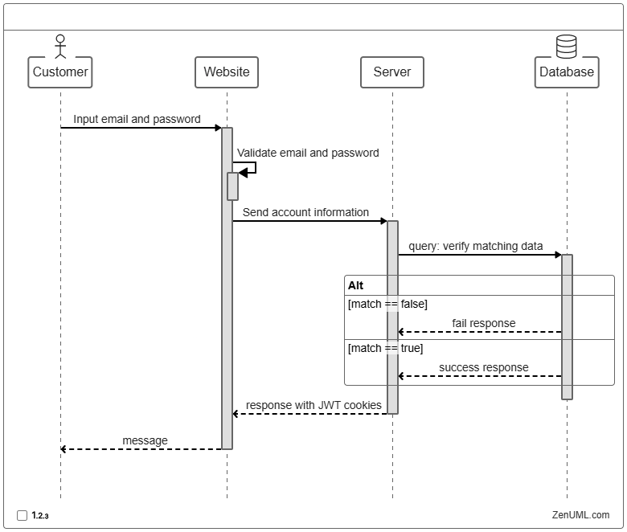

Figure : Login sequence

### 4.3.2. Register

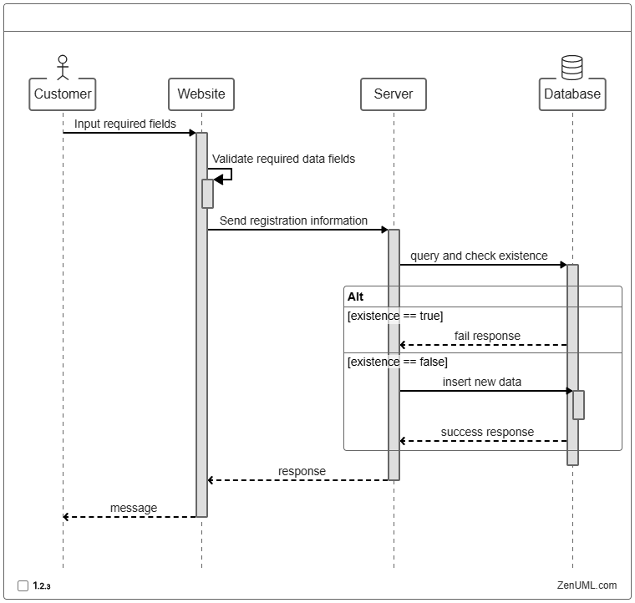

Figure : Register sequence

### 4.3.3. Reset password

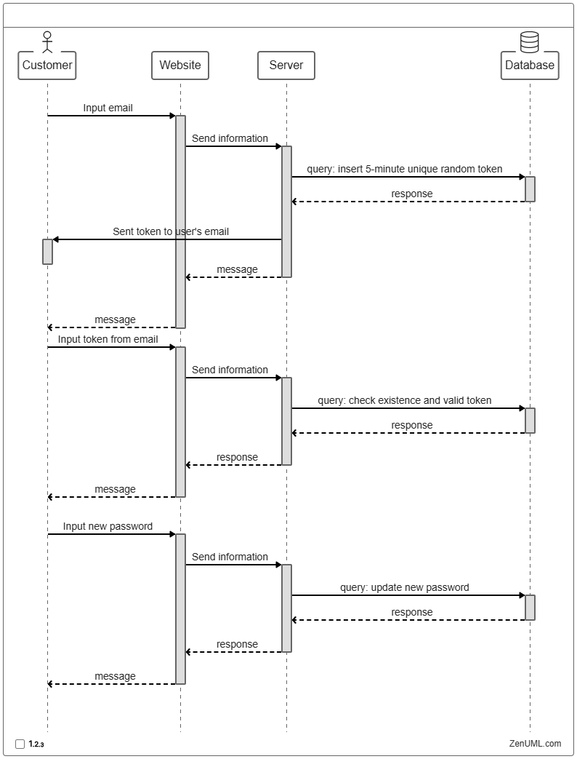

Figure : Reset password sequence

### 4.3.4. Change profile information

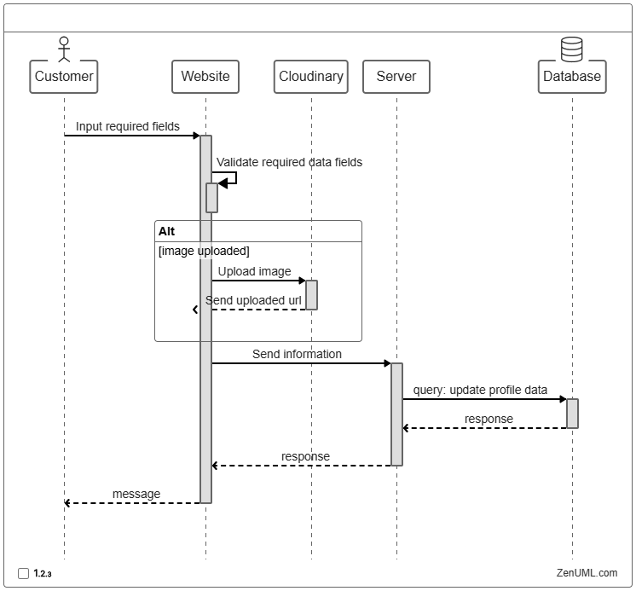

Figure : Change profile information sequence

### 4.3.5. View movie information

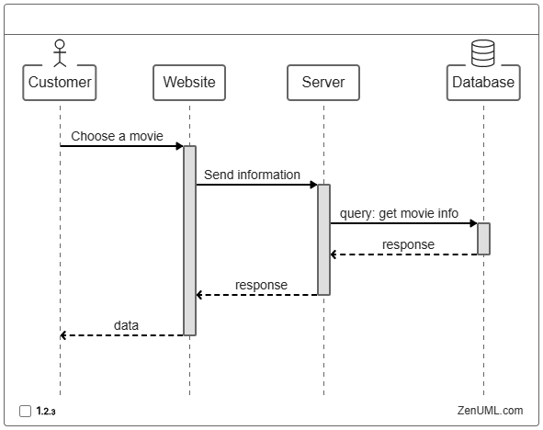

Figure : View movie information sequence

### 4.3.6. View episode information

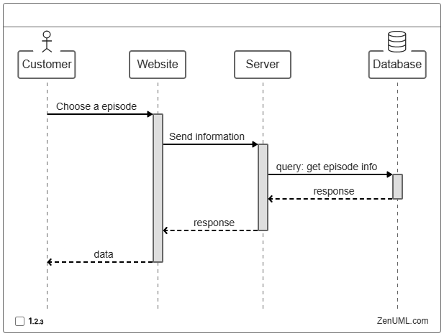

Figure : View episode information sequence

### 4.3.7. Filter movies

Figure : Filter movies sequence

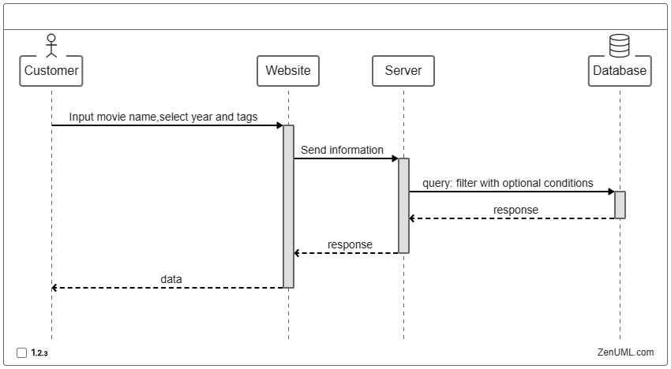

### 4.3.8. Favourite list management

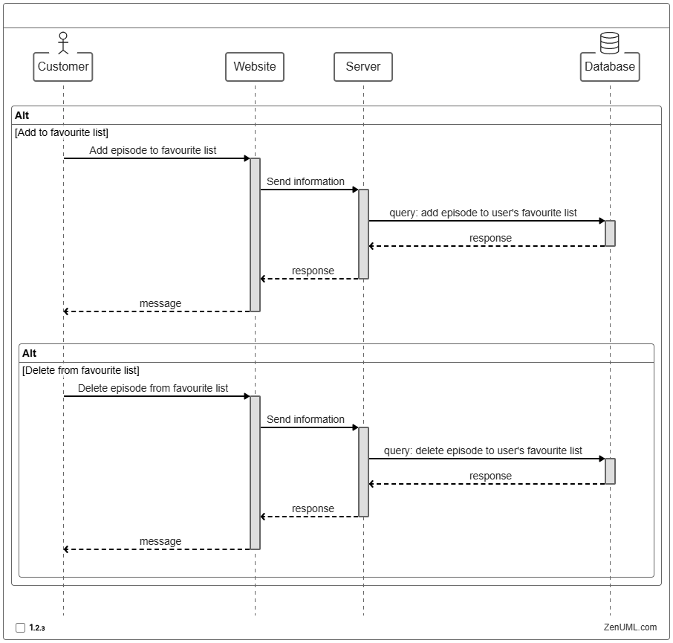

Figure : Favourite list management sequence

### 4.3.9. Manage comment

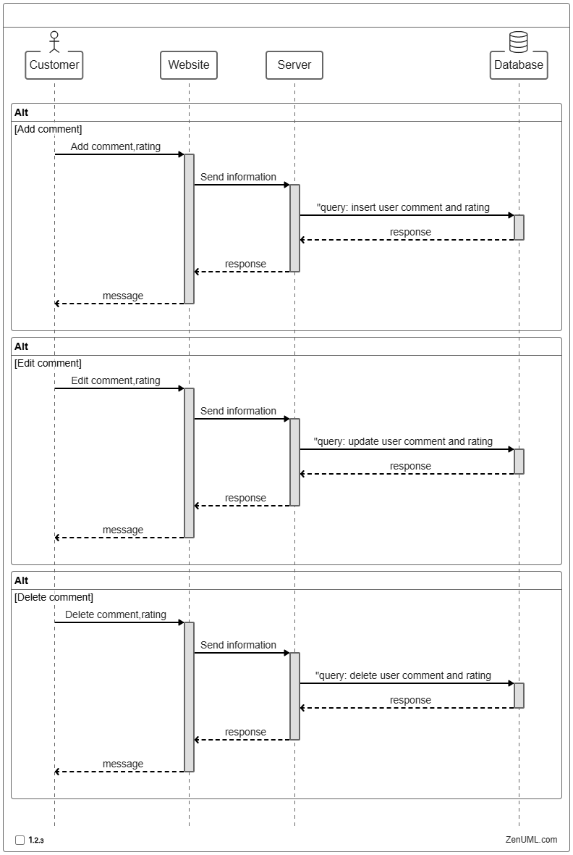

Figure : Manage comment diagrams

### 4.3.10. Active email

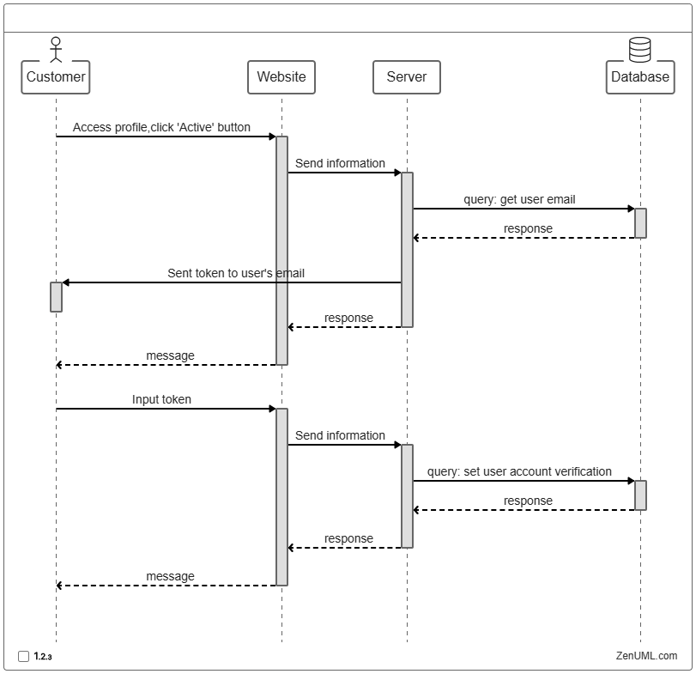

Figure : Active email sequence

### 4.3.11. Admin user management

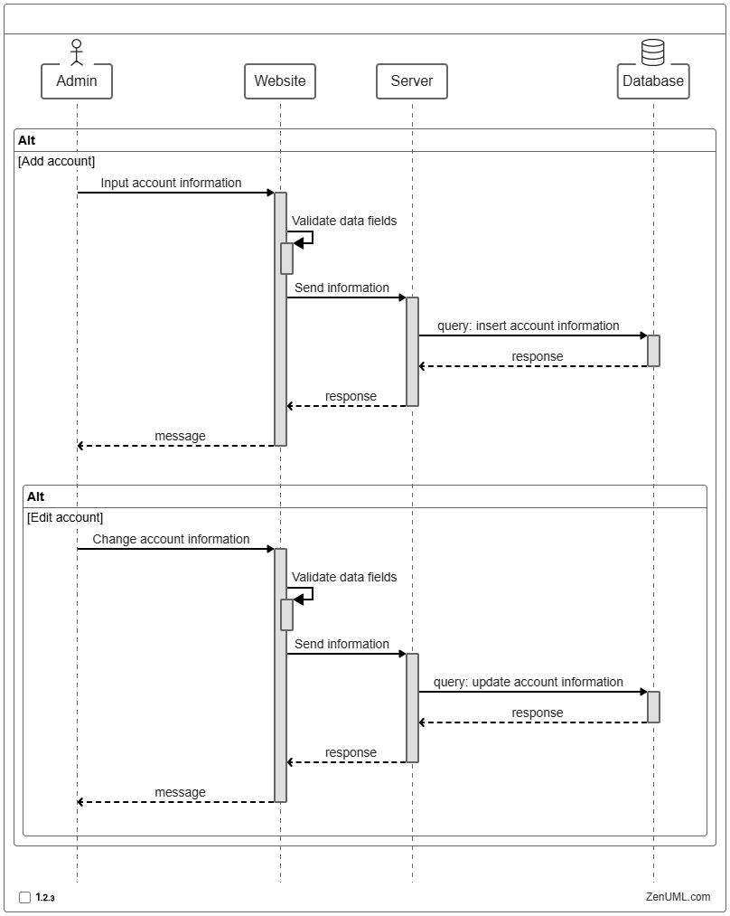

Figure : Admin user management sequence

### 4.3.12. Admin movie management

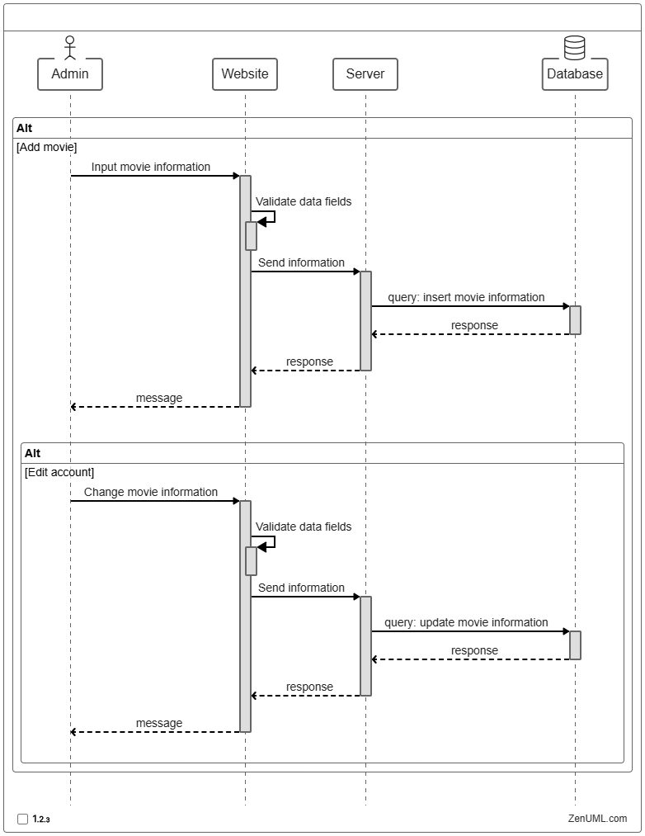

Figure : Admin movie management

### 4.3.13. Admin episode management

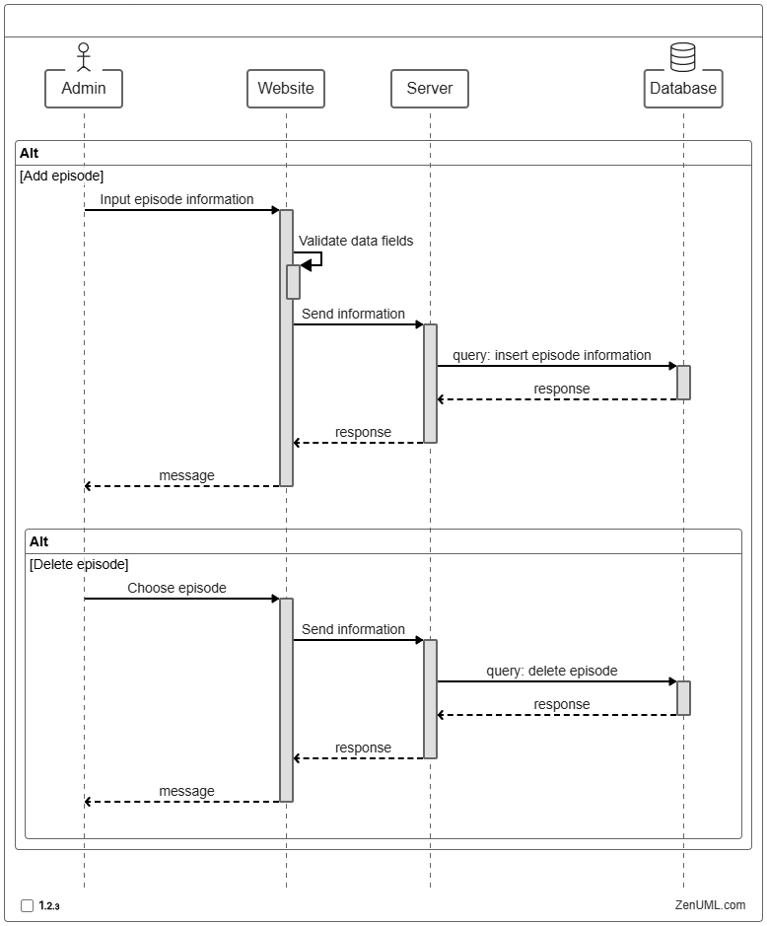

Figure : Admin episode management

### 4.3.14. Admin categories management

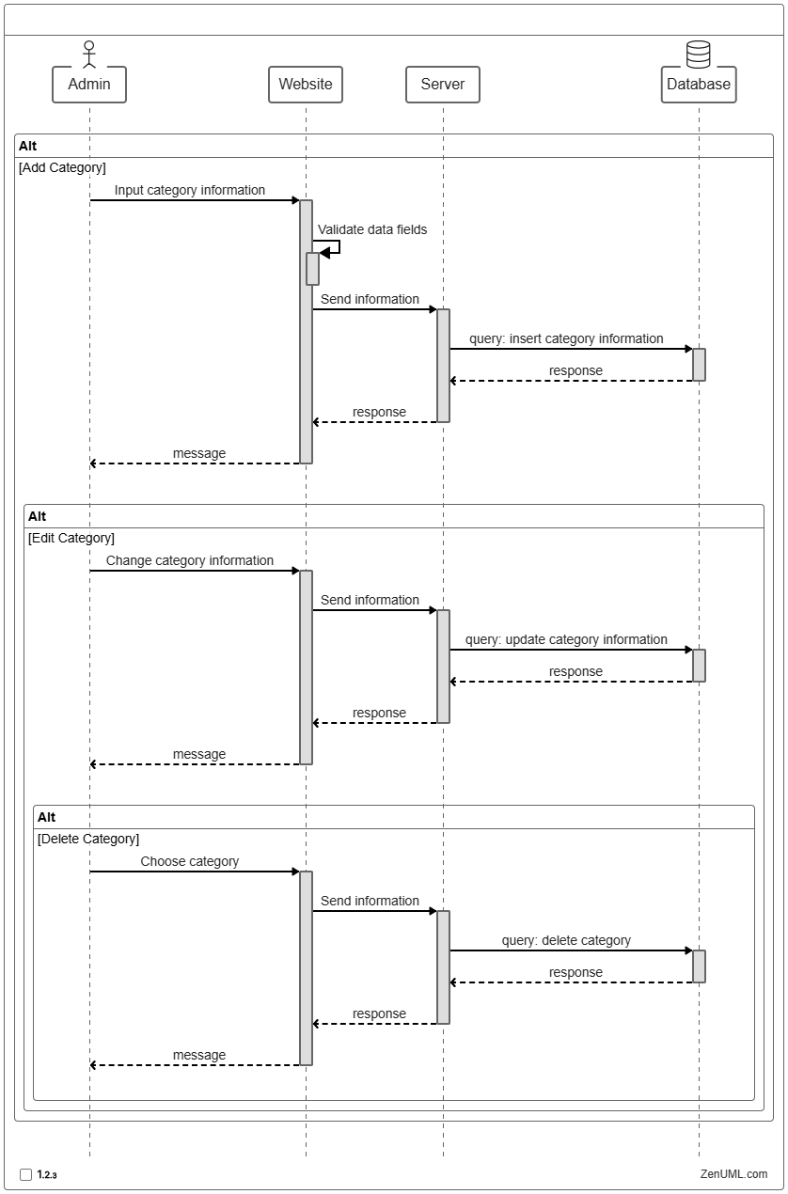

Figure : Admin categories management sequence

## 4.4. Class Diagram

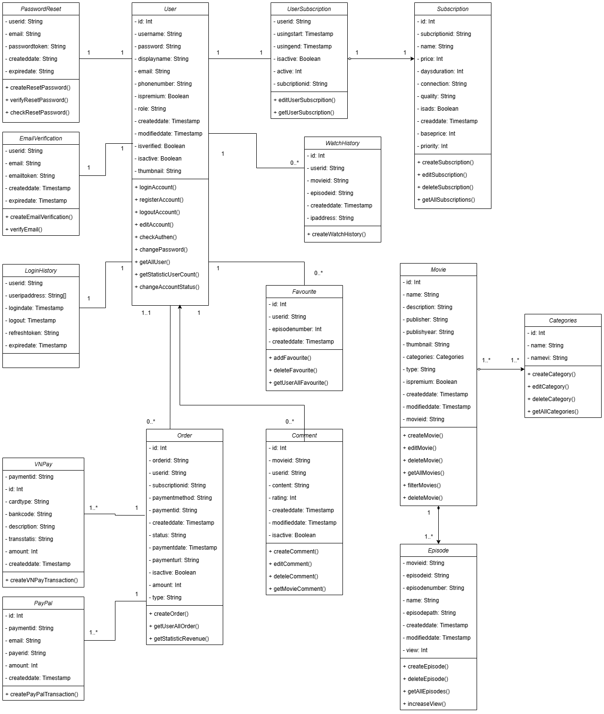

*Figure 26: Class Diagram*

## 4.5. Database

### 4.5.1. ERD

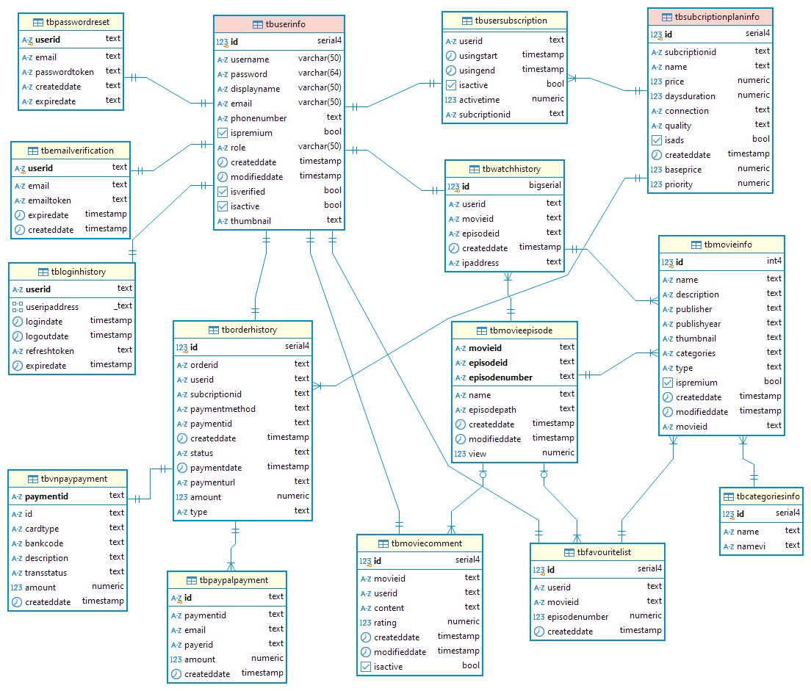

Figure : ERD

**4.5.2. Database table details**

#### **4.5.3.1. tbuserinfo table**

|  |  |  |  |  |  |
| --- | --- | --- | --- | --- | --- |
| **Ord** | **Attribute** | **Type** | **Domain** | **Meaning** | **Note** |
| 1 | id | serial4 | Primary key | Unique identifier for the user account. |  |
| 3 | username | varchar(50) |  | Username of the account. |  |
| 4 | password | varchar(64) |  | Encrypted password of the account. |  |
| 5 | displayname | varchar(50) |  | Display name visible to other users. |  |
| 6 | email | varchar(50) |  | Email address associated with the account. |  |
| 7 | phonenumber | text |  | Contact phone number of the user. |  |
| 8 | ispremium | bool |  | Indicates whether the user has a premium subscription (true/false). |  |
| 9 | role | varchar(50) |  | Role of the user (e.g., admin, moderator, user). |  |
| 10 | createddate | timestamp |  | Date and time the account was created. |  |
| 14 | modifieddate | timestamp |  | Date and time the account was last modified. |  |
| 15 | isverified | bool |  | Indicates whether the account is verified (true/false). |  |
| 16 | isactive | bool |  | Indicates whether the account is active (true/false). |  |
| 17 | thumbnail | text |  | Avatar of account |  |

*Table 35: tbuserinfo table*

#### **4.5.2.2. tbcategoriesinfo table**

|  |  |  |  |  |  |
| --- | --- | --- | --- | --- | --- |
| **Ord** | **Attribute** | **Type** | **Domain** | **Meaning** | **Note** |
| 1 | id | serial4 | Primary key | Unique identifier for the record. |  |
| 2 | name | text |  | Name of the entity in English or general format. |  |
| 3 | namevi | text |  | Name of the entity in Vietnamese. |  |

*Table 36: tbcategoriesinfo table*

#### **4.5.2.3. tbemailverification table**

|  |  |  |  |  |  |
| --- | --- | --- | --- | --- | --- |
| **Ord** | **Attribute** | **Type** | **Domain** | **Meaning** | **Note** |
| 1 | userid | text | Primary key | Unique identifier for the user. |  |
| 2 | email | text |  | Email address associated with the user account. |  |
| 3 | emailtoken | text |  | Token used for email verification purposes. |  |
| 4 | expiredate | timestamp |  | Expiration date and time for the email token. |  |
| 5 | createddate | timestamp |  | Date and time the record was created. |  |

*Table 37: tbemailverification table*

#### **4.5.2.4. tbfavouritelist table**

|  |  |  |  |  |  |
| --- | --- | --- | --- | --- | --- |
| **Ord** | **Attribute** | **Type** | **Domain** | **Meaning** | **Note** |
| 1 | id | serial4 | Primary key | Unique identifier for the favorite list entry. |  |
| 2 | userid | text |  | Unique identifier for the user. |  |
| 3 | movieid | text |  | Unique identifier for the movie. |  |
| 4 | episodenumber | text |  | Episode number associated with the movie (if applicable). |  |
| 5 | createddate | timestamp |  | Date and time the record was created. |  |

*Table 38: tbfavouritelist table*

#### **4.5.2.5. tbloginhistory table**

|  |  |  |  |  |  |
| --- | --- | --- | --- | --- | --- |
| **Ord** | **Attribute** | **Type** | **Domain** | **Meaning** | **Note** |
| 1 | userid | text | Primary key | Unique identifier for the user. |  |
| 2 | useripaddress | _text |  | List of IP addresses used by the user. |  |
| 3 | logindate | timestamp |  | Date and time the user logged in. |  |
| 4 | logoutdate | timestamp |  | Date and time the user logged out. |  |
| 5 | refreshtoken | text |  | Token used to refresh the user session. |  |
| 6 | expiredate | timestamp |  | Expiration date and time for the refresh token. |  |

*Table 39: tbloginhistory table*

#### **4.5.2.6. tbmoviecomment table**

|  |  |  |  |  |  |
| --- | --- | --- | --- | --- | --- |
| **Ord** | **Attribute** | **Type** | **Domain** | **Meaning** | **Note** |
| 1 | id | serial4 | Primary key | Unique identifier for the movie comment. |  |
| 2 | movieid | text |  | Unique identifier for the movie being commented on. |  |
| 3 | userid | text |  | Unique identifier for the user who made the comment. |  |
| 4 | content | text |  | Text content of the user's comment. |  |
| 5 | rating | numeric |  | Numeric rating given by the user (e.g., 1-5 scale). |  |
| 6 | createddate | timestamp |  | Date and time the comment was created. |  |
| 7 | modifieddate | timestamp |  | Date and time the comment was last modified. |  |
| 8 | isactive | bool |  | Indicates whether the comment is active (true/false). |  |

*Table 40: tbmoviecomment table*

#### **4.5.2.7. tbmovieepisode table**

|  |  |  |  |  |  |
| --- | --- | --- | --- | --- | --- |
| **Ord** | **Attribute** | **Type** | **Domain** | **Meaning** | **Note** |
| 1 | movieid | text | Primary key | Unique identifier for the movie. |  |
| 2 | episodeid | text |  | Unique identifier for the episode. |  |
| 3 | name | text |  | Name of the episode. |  |
| 4 | episodenumber | text |  | Number of the episode within the movie. |  |
| 5 | episodepath | text |  | Path or URL to access the episode content. |  |
| 6 | createddate | timestamp |  | Date and time the episode was created. |  |
| 7 | modifieddate | timestamp |  | Date and time the episode was last modified. |  |
| 8 | view | numeric |  | View count of the episode. |  |

*Table 41: tbmovieepisode table*

#### **4.5.2.8. tbmovieinfo table**

|  |  |  |  |  |  |
| --- | --- | --- | --- | --- | --- |
| **Ord** | **Attribute** | **Type** | **Domain** | **Meaning** | **Note** |
| 1 | id | int4 | Primary key | Unique identifier for the movie information. |  |
| 2 | name | text |  | Name of the movie. |  |
| 3 | description | text |  | Description or synopsis of the movie. |  |
| 4 | publisher | text |  | Name of the publisher or production company. |  |
| 5 | publishyear | text |  | Year the movie was published. |  |
| 6 | thumbnail | text |  | URL or path to the thumbnail image of the movie. |  |
| 7 | categories | text |  | Categories or genres the movie belongs to. |  |
| 8 | type | text |  | Type of movie (e.g., series, feature film). |  |
| 9 | ispremium | bool |  | Indicates if the movie requires a premium subscription (true/false). |  |
| 11 | createddate | timestamp |  | Date and time the movie record was created. |  |
| 12 | modifieddate | timestamp |  | Date and time the movie record was last modified. |  |
| 13 | movieid | text |  | Unique identifier for the movie. |  |

*Table 42: tbmovieinfo table*

#### **4.5.2.9. tborderhistory table**

|  |  |  |  |  |  |
| --- | --- | --- | --- | --- | --- |
| **Ord** | **Attribute** | **Type** | **Domain** | **Meaning** | **Note** |
| 1 | id | serial4 | Primary key | Unique identifier for the payment record. |  |
| 2 | orderid | text |  | Unique identifier for the order associated with the payment. |  |
| 3 | userid | text |  | Unique identifier for the user making the payment. |  |
| 4 | subcriptionid | text |  | Unique identifier for the subscription tied to the payment. |  |
| 6 | paymentmethod | text |  | Method of payment used (e.g., credit card, PayPal). |  |
| 7 | paymentid | text |  | Unique identifier for the payment transaction. |  |
| 8 | createddate | timestamp |  | Date and time the payment record was created. |  |
| 9 | status | text |  | Status of the payment (e.g., pending, completed). |  |
| 10 | paymentdate | timestamp |  | Date and time the payment was made. |  |
| 11 | paymenturl | text |  | URL for the payment gateway or receipt. |  |
| 12 | amount | numeric |  | Total amount of the payment. |  |
| 13 | type | text |  | Type of payment (e.g., subscription, one-time) |  |

*Table 43: tborderhistory table*

#### **4.5.2.10. tbpasswordreset table**

|  |  |  |  |  |  |
| --- | --- | --- | --- | --- | --- |
| **Ord** | **Attribute** | **Type** | **Domain** | **Meaning** | **Note** |
| 1 | userid | text | Primary key | Unique identifier for the user. |  |
| 2 | email | text |  | Email address associated with the user account. |  |
| 3 | passwordtoken | text |  | Token used for resetting the user's password. |  |
| 4 | createddate | timestamp |  | Date and time the password token was created. |  |
| 5 | expiredate | timestamp |  | Expiration date and time for the password token. |  |

*Table 44: tbpasswordreset table*

#### **4.5.2.11. tbpaypalpayment table**

|  |  |  |  |  |  |
| --- | --- | --- | --- | --- | --- |
| **Ord** | **Attribute** | **Type** | **Domain** | **Meaning** | **Note** |
| 1 | id | text | Primary key | Unique identifier for the payment record. |  |
| 2 | paymentid | text |  | Unique identifier for the payment transaction. |  |
| 3 | email | text |  | Email address associated with the payer. |  |
| 4 | payerid | text |  | Unique identifier for the payer. |  |
| 5 | amount | numeric |  | Amount paid in the transaction. |  |
| 6 | createddate | timestamp |  | Date and time the payment record was created. |  |

*Table 45: tbpaypalpayment table*

#### **4.5.2.12. tbsubcriptionplaninfo table**

|  |  |  |  |  |  |
| --- | --- | --- | --- | --- | --- |
| **Ord** | **Attribute** | **Type** | **Domain** | **Meaning** | **Note** |
| 1 | id | serial4 | Primary key | Unique identifier for the subscription plan. |  |
| 2 | subcriptionid | text |  | Unique identifier for the subscription plan. |  |
| 3 | name | text |  | Name of the subscription plan. |  |
| 4 | price | numeric |  | Price of the subscription plan. |  |
| 5 | daysduration | numeric |  | Duration of the subscription plan in days. |  |
| 6 | connection | text |  | Number of connections allowed in the plan. |  |
| 7 | quality | text |  | Quality of the content in the plan |  |
| 9 | isads | bool |  | Indicates whether ads are included in the plan (true/false). |  |
| 10 | createddate | timestamp |  | Date and time the subscription plan was created. |  |
| 11 | baseprice | numeric |  | Base price of the subscription plan. |  |
| 12 | priority | numeric |  | Priority level of the subscription plan (higher value indicates higher priority). |  |

*Table 46: tbsubcriptionplaninfo table*

#### **4.5.2.13. tbusersubscription table**

|  |  |  |  |  |  |
| --- | --- | --- | --- | --- | --- |
| **Ord** | **Attribute** | **Type** | **Domain** | **Meaning** | **Note** |
| 1 | userid | text |  | Unique identifier for the user. |  |
| 2 | usingstart | timestamp |  | Start date and time when the user started using the service. |  |
| 3 | usingend | timestamp |  | End date and time when the user stopped using the service. |  |
| 5 | isactive | bool |  | Indicates whether the user's subscription is currently active (true/false). |  |
| 6 | activetime | numeric |  | Amount of time the user has been active (in minutes, hours, etc.). |  |
| 7 | subcriptionid | text |  | Unique identifier for the subscription the user is using. |  |

*Table 47: tbusersubscription table*

#### **4.5.2.14. tbvnpaypayment table**

|  |  |  |  |  |  |
| --- | --- | --- | --- | --- | --- |
| **Ord** | **Attribute** | **Type** | **Domain** | **Meaning** | **Note** |
| 1 | id | text | Primary key | Unique identifier for the payment transaction. |  |
| 2 | paymentid | text |  | Unique identifier for the payment. |  |
| 3 | cardtype | text |  | Type of card used for the payment (e.g., credit, debit). |  |
| 4 | bankcode | text |  | Code of the bank where the payment was processed. |  |
| 5 | description | text |  | Description or additional details of the payment. |  |
| 6 | transstatus | text |  | Status of the transaction (e.g., successful, failed). |  |
| 7 | amount | numeric |  | Amount of the payment transaction. |  |
| 8 | createddate | timestamp |  | Date and time when the payment was created. |  |

*Table 48: tbvnpaypayment table*

#### **4.5.2.15. tbwatchhistory table**

|  |  |  |  |  |  |
| --- | --- | --- | --- | --- | --- |
| **Ord** | **Attribute** | **Type** | **Domain** | **Meaning** | **Note** |
| 1 | id | bigserial | Primary key | Unique identifier for the watch history record. |  |
| 2 | userid | text |  | Unique identifier for the user who watched the content. |  |
| 3 | movieid | text |  | Unique identifier for the movie that was watched. |  |
| 4 | episodeid | text |  | Unique identifier for the episode (if applicable) that was watched. |  |
| 5 | createddate | timestamp |  | Date and time when the watch history record was created. |  |
| 6 | ipaddress | text |  | IP address of the user who watched the content. |  |

*Table 49: tbwatchhistory table*

## 4.6. Application interfaces

### 4.6.1. Guest

#### 4.6.1.1. Register page

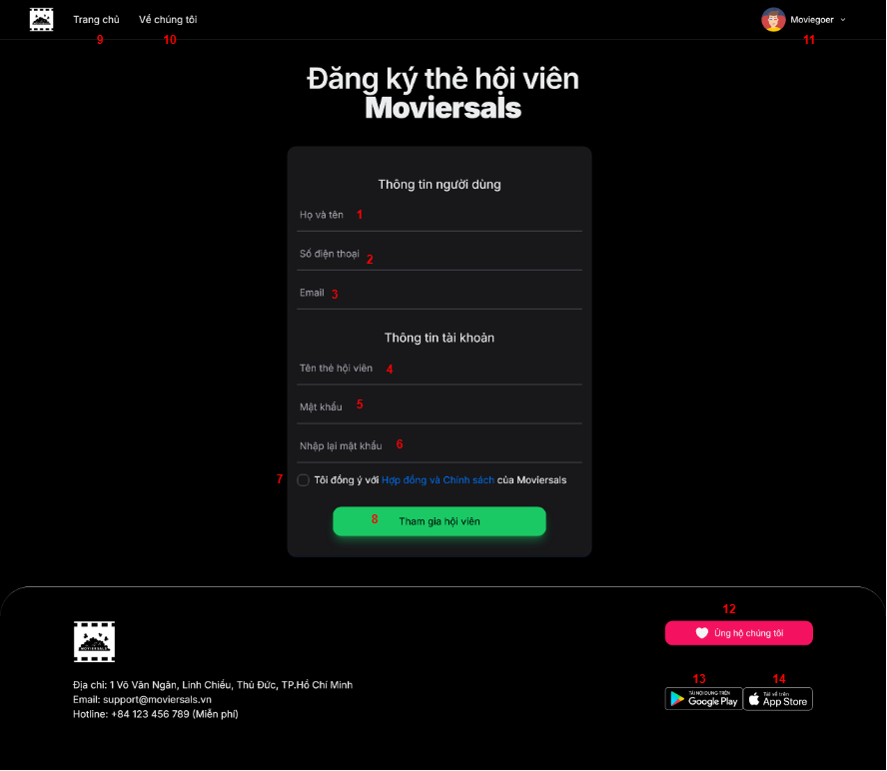

Figure : Register Page

Table : Register Page Object

|  |  |  |  |
| --- | --- | --- | --- |
| No | Name | Format | Action |
| 1 | Fullname | Textbox | For guest to input fullname |
| 2 | Phone number | Textbox | For guest to input phone number |
| 3 | Email | Textbox | For guest to input email |
| 4 | Username | Textbox | For guest to input username |
| 5 | Password | Textbox | For guest to input password |
| 6 | Repeat Password | Textbox | For guest to repeat password |
| 7 | Confirm Policy | Checkbox | For guest to confirm policy of the website |
| 8 | Register | Button | For guest to register account |
| 9 | Homepage | Text | For guest to redirect to homepage |
| 10 | About us | Text | For guest to redirect to about us page |
| 11 | Username | Text | Show current user’s fullname |
| 12 | Donate | Button | For user to donate |
| 13 | Google Play | Button | For user to download android mobile app (not developed yet) |
| 14 | Appstore | Button | For user to download ios mobile app (not developed yet) |

#### 4.6.1.2. Reset password page



Figure : Reset password page

Table : Reset Password Page Object

|  |  |  |  |
| --- | --- | --- | --- |
| No | Name | Format | Action |
| 1 | Email | Textbox | For guest to enter email |
| 2 | Send email | Button | For guest to send code to email |

#### 4.6.1.3. Login page

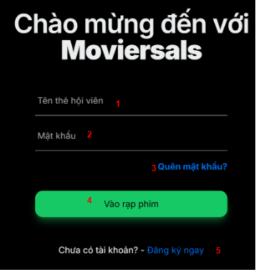

Figure : Login Page

Table . Login Page Object

|  |  |  |  |
| --- | --- | --- | --- |
| No | Name | Format | Action |
| 1 | username | Textbox | For guest to input username |
| 2 | Password | Textbox | For guest to input password |
| 3 | Forgot Password | Text | For guest to redirect to forgot password page |
| 4 | Login | Button | For guest to login |
| 5 | Register | Text | For guest to redirect to register page |

#### 4.6.1.4. Policy page

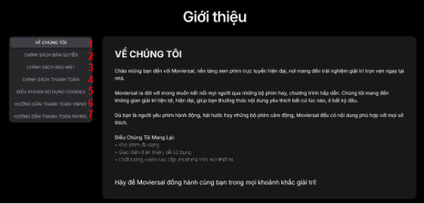

Figure . Policy Page

Table . Policy Page Objects

|  |  |  |  |
| --- | --- | --- | --- |
| No | Name | Format | Action |
| 1 | Home | Button | For customer to return to home page |
| 2 | Username | Text | For customers to input username |
| 3 | Password | Text | For customers to input password |
| 4 | Forgot password | Button | For customer to reset password page |
| 5 | Sign in | Button | For customer to send login request to the system |
| 6 | Create account | Button | For customer to go to the register page |

### 4.6.2. Customer

#### 4.6.2.1. Customer’s Homepage

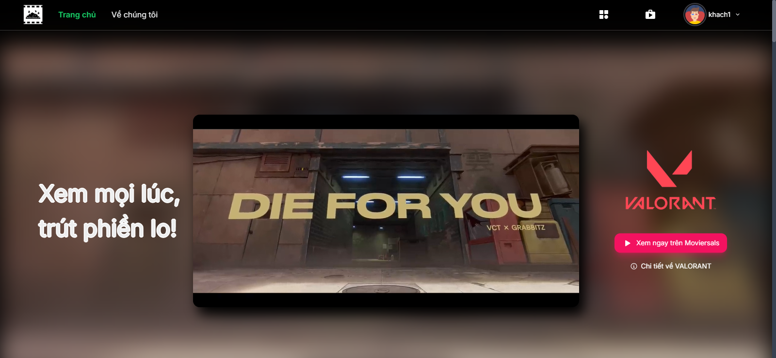

Figure : Customer's Homepage

Table : Customer's Homepage Object

|  |  |  |  |
| --- | --- | --- | --- |
| No | Name | Format | Action |
| 1 | Translation | Button | For customer to open translation popup |
| 2 | Customer avatar | Image | Display customer avatar image |
| 3 | Customer name | Text | Display customer avatar name |
| 4 | Profile | Button | For customer to view the customer profile |
| 5 | Logout | Button | For customers to send a logout request to the system |
| 6 | Shop logo | Image | Display shop logo |
| 7 | Search | Text | For customer to input anything for search product |
| 8 | Search | Button | For customer to send search request to the system |
| 9 | Invoice | Button | For customer to go to the customer invoice page |
| 10 | Shop | Button | For customer to go to the customer shop page |
| 11 | Categories | Button | Display all category of product |
| 12 | Banner | Image | Display shop banner |

#### 4.6.2.2. Profile Page

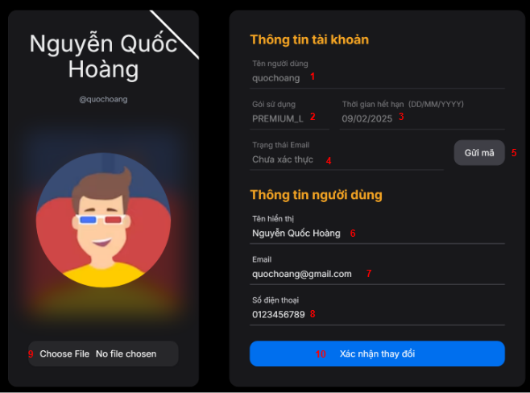

Figure . Profile Page

Table : Profile Page Object

|  |  |  |  |
| --- | --- | --- | --- |
| No | Name | Format | Action |
| 1 | User’s Username | Textbox | Display user’s username |
| 2 | User’s Subscription | Textbox | Display user’s subscription |
| 3 | End date | Textbox | Display user’s subscription end date |
| 4 | Email Status | Textbox | Display user’s email status |
| 5 | Send Code | Button | For user to send request to get email confirmation code |
| 6 | User’s Fullname | Textbox | Display user’s fullname |
| 7 | User’s Email | Textbox | Display user’s email |
| 8 | User’s Phone Number | Textbox | Display user’s phone number |
| 9 | Choose file | Button | For user to choose image file |
| 10 | Confirm change | Button | For user to confirm profile editing |

#### 4.6.2.3. Subscription Page

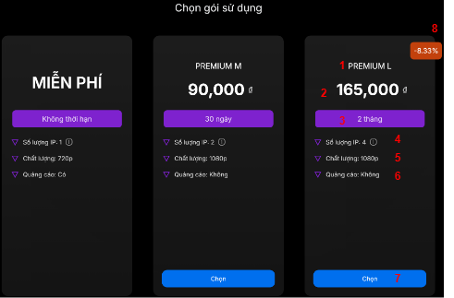

Figure : Subscription Page 1

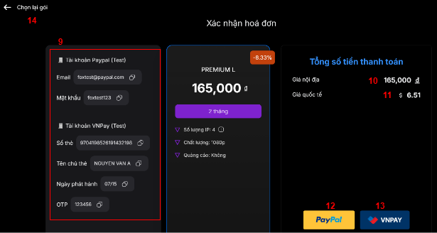

Figure : Subscription Page 2

Table : Subscription Page Object

|  |  |  |  |
| --- | --- | --- | --- |
| No | Name | Format | Action |
| 1 | Subscription Name | Text | Display subscription name |
| 2 | Subscription Fee | Text | Display subscription fee |
| 3 | Subscription Length | Text | Display subscription length |
| 4 | Subscription Allow IP Number | Text | Display subscription allow IP number |
| 5 | Subscription Max Resolution | Text | Display subscription max resolution |
| 6 | Subscription Ad Status | Text | Display subscription ad status |
| 7 | Choose Subscription | Button | For user to choose subscription |
| 8 | Subscription Sale | Text | Display subscription sale |
| 9 | Payment Test Account Information | Multi Textbox | Display payment test account information |
| 10 | Subscription Fee  (VND) | Text | Display subscription fee in VND |
| 11 | Subscription Fee  (USD) | Text | Display subscription fee in USD |
| 12 | PayPal | Button | For customer to choose PayPal payment method |
| 13 | VNPay | Button | For customer to choose VNPay payment method |
| 14 | Back To Subscription Selection | Text | For user to back to subscription selection page |

#### 4.6.2.5. Order History Page

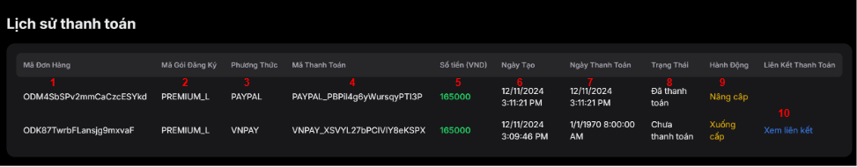

Figure : Order History Page

Table : Order History Page Objects

|  |  |  |  |
| --- | --- | --- | --- |
| No | Name | Format | Action |
| 1 | Order ID | Text | Display order id |
| 2 | Subscription Name | Text | Display subscription name |
| 3 | Payment Method | Text | Display payment method |
| 4 | Payment ID | Text | Display payment id |
| 5 | Fee | Text | Display fee |
| 6 | Created Date | Text | Display created date |
| 7 | Paid Date | Text | Display paid date |
| 8 | Status | Text | Display status |
| 9 | Action | Text | Display action |
| 10 | Payment Link | Text | For user to redirect to payment link |

#### 4.6.2.6. Categories Page

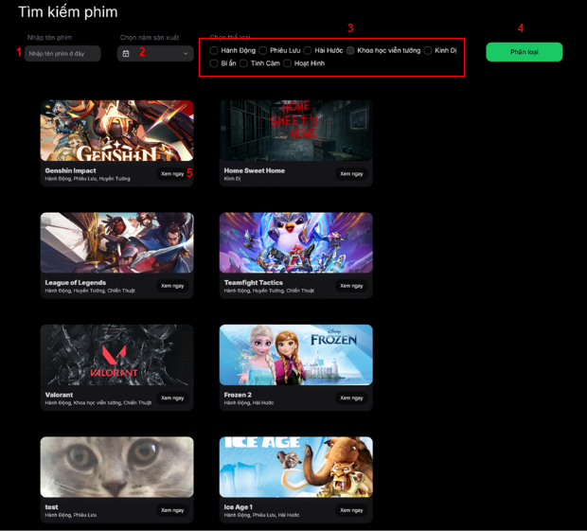

Figure : Categories Page

Table : Categories Page Objects

|  |  |  |  |
| --- | --- | --- | --- |
| No | Name | Format | Action |
| 1 | Filter Movie Name | Textbox | For user to input movie name |
| 2 | Filter Movie Produced Year | Dropdown | For user to choose movie produced year |
| 3 | Filter Movie Categories | Checkbox | For user to choose movie categories |
| 4 | Filter | Button | For user to filter movie |
| 5 | Watch Now | Button | For user to redirect to movie detail page |

#### 4.6.2.7. Movie Detail Page

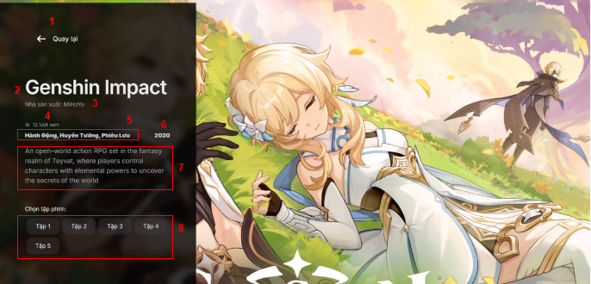

Figure : Movie Detail Page

Table : Movie Detail Page Objects

|  |  |  |  |
| --- | --- | --- | --- |
| No | Name | Format | Action |
| 1 | Back | Text | For user to go back to previous page |
| 2 | Movie Name | Text | Display movie name |
| 3 | Movie Producer | Text | Display movie producer |
| 4 | Movie Views | Text | Display movie views |
| 5 | Movie Categories | Text | Display movie categories |
| 6 | Movie Published Date | Text | Display movie published date |
| 7 | Movie Description | Text | Display movie description |
| 8 | Movie Episodes | Text | For user to select episode to watch |

#### 4.6.2.8. Movie Episode Page

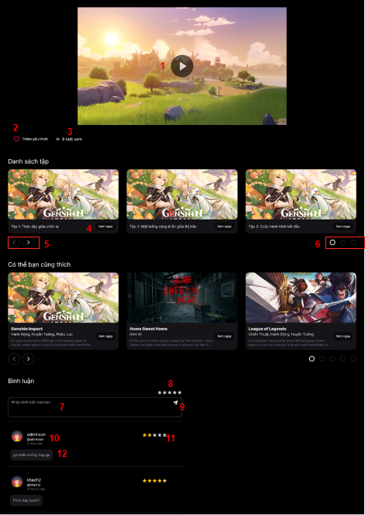

Figure : Movie Detail Page

Table : Movie Episode Page Objects

|  |  |  |  |
| --- | --- | --- | --- |
| No | Name | Format | Action |
| 1 | Play | Button | For user to play video |
| 2 | Favourite | Button | For user to add movie to favourite |
| 3 | Views | Text | Display episode views |
| 4 | Watch Now | Button | For user to watch other episode |
| 5 | Navigate | Button | For user to scroll episodes |
| 6 | Pagination | Button | For user to scroll episodes |
| 7 | Comment | Text | For user to input comment |
| 8 | Rating | Slider | For user to select rating |
| 9 | Submit | Text | For user to submit comment/rating |
| 10 | Username | Text | Display username who commented |
| 11 | Rating | Slider | Display rating of the comment |
| 12 | Comment | Text | Display comment |

#### 4.6.2.9. Favourite Page



Figure : Favourite Page

Table : Favourite Page Objects

|  |  |  |  |
| --- | --- | --- | --- |
| No | Name | Format | Action |
| 1 | Favourite | Button | For user to remove movie from favourite |
| 2 | Movie Name | Text | Display movie name |
| 3 | Added Date | Text | Display movie added to favourite date |

### 4.6.3. Admin

#### 4.6.3.1. Admin Page

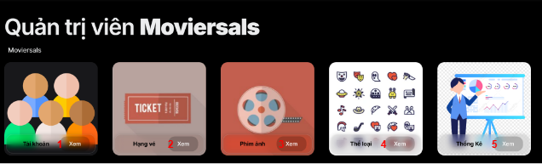

Figure : Admin Page

Table : Admin Page Objects

|  |  |  |  |
| --- | --- | --- | --- |
| No | Name | Format | Action |
| 1 | Manage User | Button | For admin to redirect to admin user page |
| 2 | Manage Subscription | Button | For admin to redirect to admin subscription page |
| 3 | Manage Movie | Button | For admin to redirect to admin movie page |
| 4 | Manage Categories | Button | For admin to redirect to admin categories page |
| 5 | View Statistic | Button | For admin to redirect to statistic page |

#### 4.6.3.2. Admin User Page

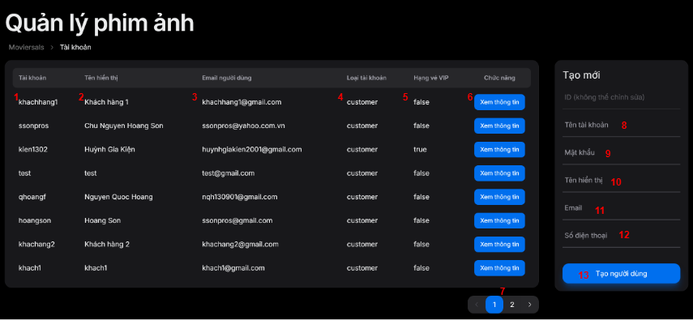

Figure : Admin User Page

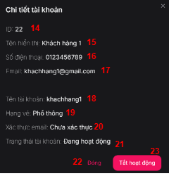

Figure : User Detail Panel

Table : Admin User Page Objects

|  |  |  |  |
| --- | --- | --- | --- |
| No | Name | Format | Action |
| 1 | Username | Text | Displays username |
| 2 | Fullname | Text | Displays user fullname |
| 3 | Email | Text | Displays user email |
| 4 | User Type | Text | Displays user type |
| 5 | VIP | Text | Displays user VIP status |
| 6 | Function | Button | For admin to open user information panel |
| 7 | Navigate | Button | For admin to navigate to other pages |
| 8 | Username | Textbox | For admin to input new account username |
| 9 | Password | Textbox | For admin to input new account password |
| 10 | Fullname | Textbox | For admin to input new account fullname |
| 11 | Email | Textbox | For admin to input new account email |
| 12 | Phone Number | Textbox | For admin to input new account phone number |
| 13 | Create User | Button | For admin to create new account |
| 14 | User ID | Text | Display user id |
| 15 | Fullname | Text | Display user fullname |
| 16 | Phone Number | Text | Display user phone number |
| 17 | Email | Text | Display user email |
| 18 | Username | Text | Display user username |
| 19 | Subscription | Text | Display user subscription plan |
| 20 | Email Status | Text | Display user email status |
| 21 | Status | Text | Display user account status |
| 22 | Close | Button | For admin to close panel |
| 23 | Deactivate | Button | For admin to deactive user account |

#### 4.6.3.3. Admin Subscription Page

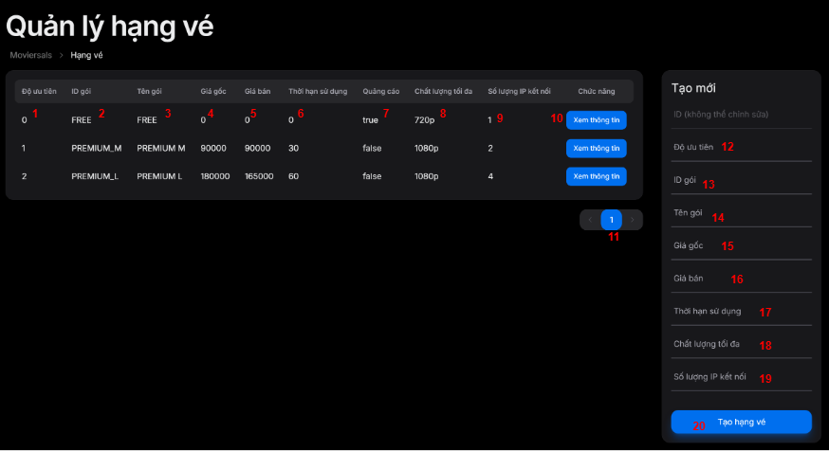

Figure : Admin Subscription Page

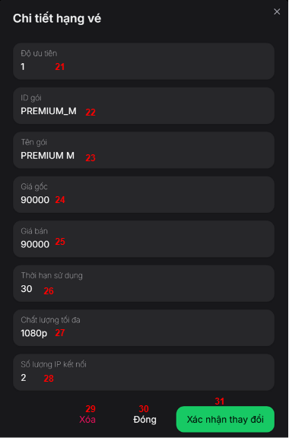

Figure : Subscription Detail Panel

Table : Admin Subscription Page

|  |  |  |  |
| --- | --- | --- | --- |
| No | Name | Format | Action |
| 1 | Priority | Text | Display subscription priority |
| 2 | Subscription ID | Text | Display subscription id |
| 3 | Subscription Name | Text | Display subscription name |
| 4 | Base Price | Text | Display subscription base price |
| 5 | Sell Price | Text | Display subscription sell price |
| 6 | Expiration Date | Text | Display subscription expiration date |
| 7 | Ad Status | Text | Display subscription ad status |
| 8 | Max Quality | Text | Display subscription max quality |
| 9 | Max IP Connection | Text | Display subscription max ip connection |
| 10 | View Information | Button | For admin to open subscription information panel |
| 11 | Navigate | Button | For admin to navigate to other pages |
| 12 | Priority | Textbox | For admin to input new subscription priority |
| 13 | Subscription ID | Textbox | For admin to input new subscription priority |
| 14 | Subscription Name | Textbox | For admin to input new subscription priority |
| 15 | Base Price | Textbox | For admin to input new subscription priority |
| 16 | Sell Price | Textbox | For admin to input new subscription priority |
| 17 | Expiration Date | Textbox | For admin to input new subscription priority |
| 18 | Ad Status | Textbox | For admin to input new subscription priority |
| 19 | Max Quality | Textbox | For admin to input new subscription priority |
| 20 | Create Subscription | Button | For admin to create new subscription |
| 21 | Priority | Text | Display subscription priority |
| 22 | Subscription ID | Text | Display subscription id |
| 23 | Subscription Name | Text | Display subscription name |
| 24 | Base Price | Text | Display subscription base price |
| 25 | Sell Price | Text | Display subscription sell price |
| 26 | Expiration Date | Text | Display subscription expiration date |
| 27 | Max Quality | Text | Display subscription max quality |
| 28 | Max IP Connection | Text | Display subscription max ip connection |
| 29 | Delete | Button | For admin to delete subscription plan |
| 30 | Close | Button | For admin to close panel |
| 31 | Confirm Change | Button | For admin to confirm change |

#### 4.6.3.3. Admin Movie Page

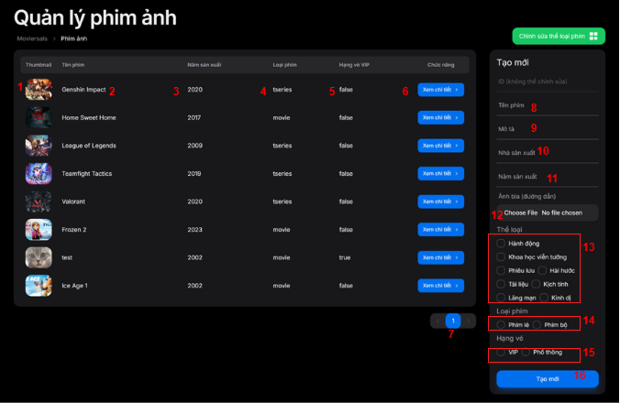

Figure : Admin Movie Page

Table . Admin Movie Page

|  |  |  |  |
| --- | --- | --- | --- |
| No | Name | Format | Action |
| 1 | Thumbnail | Image | Display movie thumbnail |
| 2 | Movie Name | Text | Displays movie name |
| 3 | Published Year | Text | Displays movie published year |
| 4 | Movie Type | Text | Displays movie type |
| 5 | VIP | Text | Displays movie VIP status |
| 6 | View | Text | For admin to redirect to admin episode page |
| 7 | Navigate | Text | For admin to navigate to other pages |
| 8 | Movie Name | Textbox | For admin to input movie name |
| 9 | Description | Textbox | For admin to input movie description |
| 10 | Producer | Textbox | For admin to input movie producer |
| 11 | Published Year | Textbox | For admin to input movie published year |
| 12 | Choose Thumbnail | Button | For admin to choose movie thumbnail |
| 13 | Categories | Checkbox | For admin to choose movie categories |
| 14 | Movie Type | Radio Button | For admin to choose movie type |
| 15 | Subscription | Radio Button | For admin to input movie description |
| 16 | Create New | Button | For admin to create new movie |
| 17 | Manage Categories | Button | For admin to redirect to admin categories page |

#### 4.6.3.4. Admin Movie Detail Page

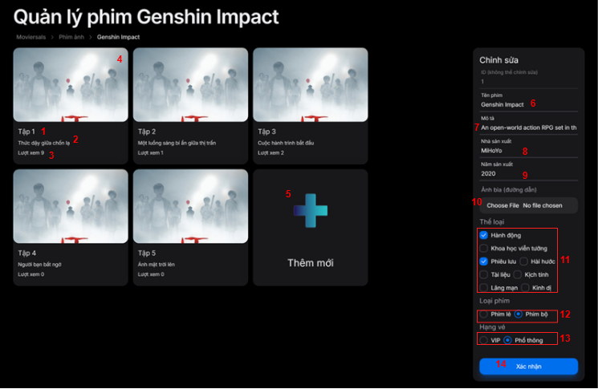

Figure : Admin Movie Detail Page

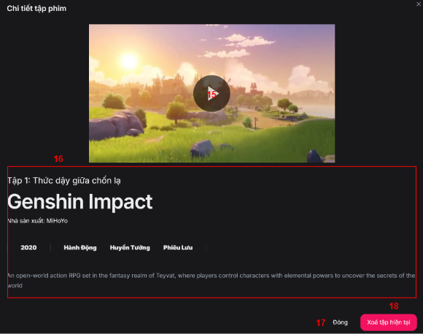

Figure : Admin Episode Detail Panel

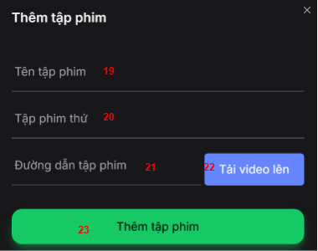

Figure : Admin Add Episode Panel

Table : Admin Movie Detail Page

|  |  |  |  |
| --- | --- | --- | --- |
| No | Name | Format | Action |
| 1 | Episode | Text | Display episode |
| 2 | Episode Name | Text | Display episode name |
| 3 | Episode Views | Text | Display episode views |
| 4 | Episode Thumbnail | Image | Display episode thumbnail and for admin to open episode detail panel |
| 5 | Add Episode | Button | For admin to open add episode panel |
| 6 | Movie Name | Textbox | For admin to input movie name |
| 7 | Description | Textbox | For admin to input movie description |
| 8 | Producer | Textbox | For admin to input movie producer |
| 9 | Published Year | Textbox | For admin to input movie published year |
| 10 | Choose Thumbnail | Button | For admin to choose movie thumbnail |
| 11 | Categories | Checkbox | For admin to choose movie categories |
| 12 | Movie Type | Radio Button | For admin to choose movie type |
| 13 | Subscription | Radio Button | For admin to input movie description |
| 14 | Confirm | Button | For admin to edit movie information |
| 15 | Play | Button | For admin to play episode |
| 16 | Episode Information | Text | Display episode information |
| 17 | Close | Button | For admin to close admin episode detail panel |
| 18 | Delete Episode | Button | For admin to delete episode |
| 19 | Episode Name | Textbox | For admin to input episode name |
| 20 | Episode Number | Textbox | For admin to input episode number |
| 21 | Episode Path | Textbox | For admin to input episode path |
| 22 | Upload Episode | Button | For admin to upload episode |
| 23 | Add Episode | Button | For admin to add episode |

#### 4.6.3.5. Admin Categories Page

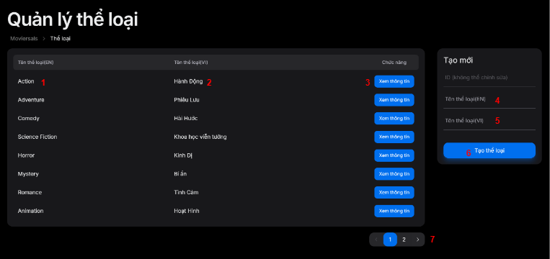

Figure : Admin Categories Page

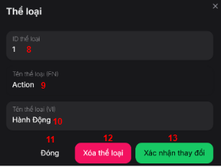

Figure : Admin Category Detail Panel

Table : Admin Categories Page Objects

|  |  |  |  |
| --- | --- | --- | --- |
| No | Name | Format | Action |
| 1 | Category name  (ENG) | Text | Displays images of the product |
| 2 | Category name  (VI) | Text | Displays name of the product |
| 3 | View Information | Button | Open admin category detail panel |
| 4 | Category name  (ENG) | Textbox | For user to input new category name (ENG) |
| 5 | Category name  (VI) | Textbox | For user to input new category name (VI) |
| 6 | Create Category | Button | For admin to create new category |
| 7 | Navigate | Button | For admin to navigate to other pages |
| 8 | Category ID | Textbox | Display category id |
| 9 | Category Name  (ENG) | Text | Display category name (ENG) |
| 10 | Category Name  (VI) | Textbox | For admin to edit category name (VI) |
| 11 | Close | Button | For admin to close categories detail panel |
| 12 | Delete Category | Button | For admin to delete categories |
| 13 | Confirm Change | Button | For admin to confirm category change |

#### 4.6.3.6. Admin Statistic Page

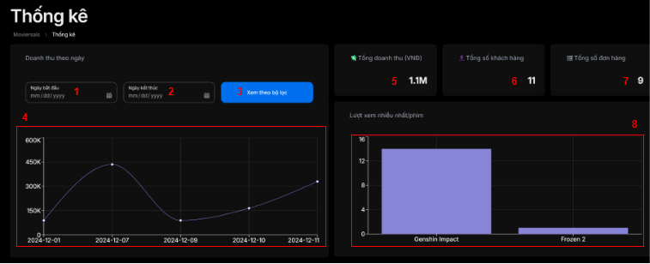

Figure : Admin Statistic Page

Table : Admin Statistic Page Objects

|  |  |  |  |
| --- | --- | --- | --- |
| No | Name | Format | Action |
| 1 | Start Date | Datetime Picker | For admin to select start date to filter |
| 2 | End Date | Datetime Picker | For admin to select end date to filter |
| 3 | View By Filtered Date | Button | For admin to filter revenue chart by start and end date |
| 4 | Revenue Chart | Chart | Display total |
| 5 | Total Revenue | Text | Display total revenue |
| 6 | Total Customer | Text | Display total customer |
| 7 | Total Order | Text | Display total order |
| 8 | Views Chart | Chart | Display views chart |

# 

# CHAPTER 05: IMPLEMENTATION AND TESTING

## 5.1. Implementation

### 5.1.1. Environment

First, our backend is development by PostgreSQL database, we use PostgreSQL to store data.



Figure : PostgreSQL Database

Also, using Supabase which is similar to PostgresSQL to store data for deployed production website.



Figure : Supabase Service

And use Cloudinary to store all about thumbnails and movies



Figure . Cloudinary

After selecting the database for our project we choose VSCode is an extremely popular and very positive IDE for developers to create projects because of the convenient of VSCode which can add extensions of the programming language to help them run on IDE easily. Moreover, VSCode has the extension visual studio live share extension can let we join the project together on the host IDE and we can code or debug together, we can log in that extension via GitHub.



Figure : Code Environment

### 5.1.2. Technology

First, the base technology we use to code around our project is ReactJS, that base on JavaScript programming language using Functional Component to create function for our project instead of Class Component.



Figure : ReactJS & NextJS

About Back-end development, we use Sping Boot framework of JAVA to write API, access to database and run handle events interacting with Google and Firebase.



Figure : NodeJS & ExpressJS

### 5.1.3. Project file structure

#### 5.1.3.1. Back-end file structure

- This is our Back-end file structure.

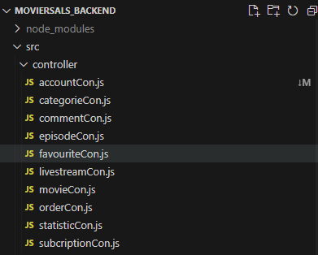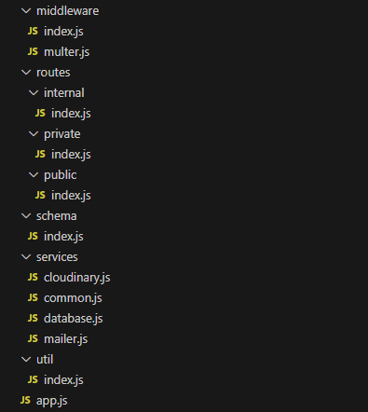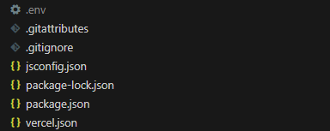

Figure . Back-end file structure

#### 5.1.3.2. Front-end file structure

- This is our Front-end file structure.

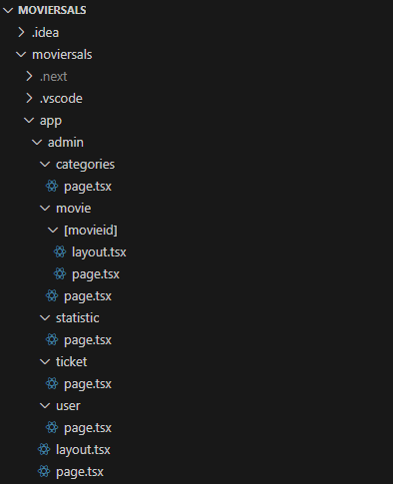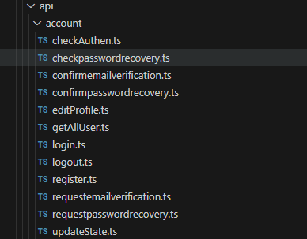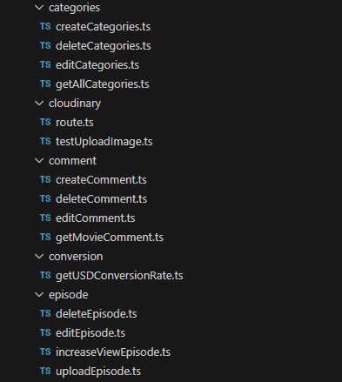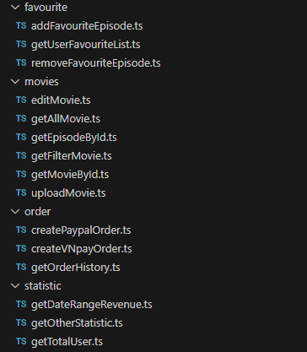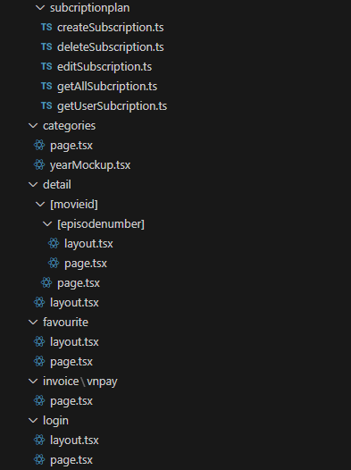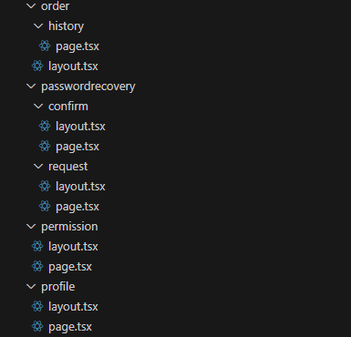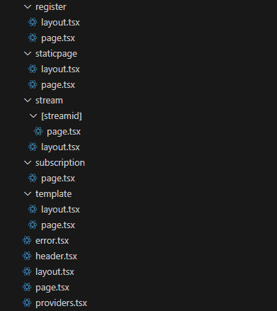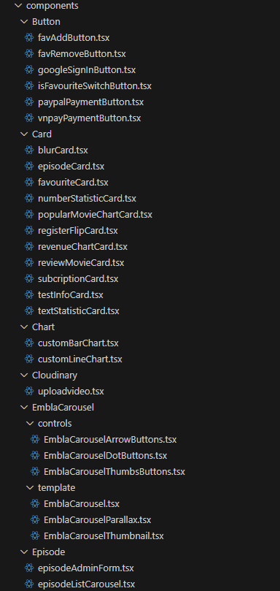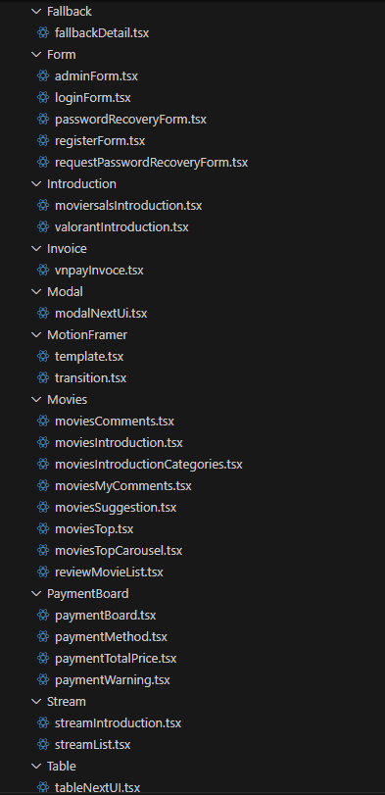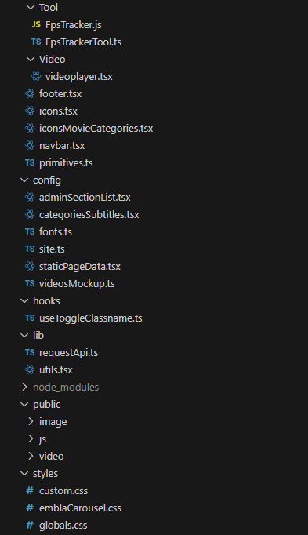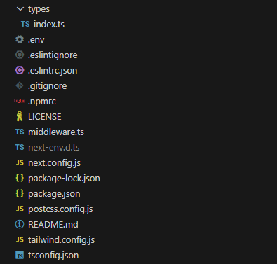

Figure : Front-end file structure

## 5.2. Deploymentation

We deploy Front-end, Back-end on Vercel, database on Supabase, images and videos on Cloudinary.

Link website and account information:

Table . Production test accounts

|  |  |  |  |
| --- | --- | --- | --- |
| Link website | Username | Password | Role |
| https://moviersals.vercel.app/ | admin | admin | admin |
| khach1 | 123456 | customer |

## 5.3. Testing

Table . Testcases

|  |  |  |  |  |  |  |
| --- | --- | --- | --- | --- | --- | --- |
| **ID** | **Description** | **Test steps** | **Test data** | **Expected Result** | **Actual Result** | **Status** |
| **TC_01** | Login with a valid account | * 1. Enter email and password   2.Click submit | Email: khach1  Password:  123456 | Notification: “Login successfully” and direct to Home Page | Notification: “Login successfully” and direct to Home Page | Pass |
| **TC_02** | Log in with an account that doesn't exist | * + 1. Enter email and password   2.Click submit | Email: khach123  Password: 123456 | Notification:” Error; account does not exist” | Notification:” Error; account does not exist” | Pass |
| **TC_03** | Log in with an account that is the wrong password | 1.Enter email and password  2.Click submit | Email: khach1  Password: 12345678 | Notification:” Login Error; Password is incorrect” | Notification:” Login Error; Password is incorrect” | Pass |
| **TC_06** | Register with valid information | 1.Access website  2.Click on Account button on the top right  2.Click register button  3.Enter email  4.Enter username  5.Enter password  6.Click register | Email: khach2  User name:  khach2  Password: khach2 | Register successfully and direct to Login Page | Register successfully and direct to Login Page | Pass |
| **TC_09** | Customer add movie to favorite | 1.Login by customer  2.Click a heart icon below movie |  | -Icon heart filled with pink color and the page favorite will add the movie into | -Icon fill pink and movie has added to favorite page. | Pass |
| **TC_10** | View Favorite Page | 1.Login by customer  2.Select Wishlist in header  3.Show the list customer has added before |  | The list showed | The list showed | Pass |

# CHAPTER 06: CONCLUSION

## 6.1. Achievements

### 6.1.1. Knowledge and skills

* We gained a lot of insight into ReactJS, NextJS, NodeJS, ExpressJS, PostgreSQL, ... and learned how to build front-end websites, back-end websites, write API, build databases and connect them. We could also understand and apply other practical features into our projects such as deployment, ... Moreover, we could also improve our ability to develop and maintain a basic system, create and enhance business logic to complete the application .
* Teamwork skills had a big leap of improvement. Additionally, time and assignment management had a strong raise after doing this project because we had to balance the time of working on this project and the time at work or at school.
* Making an online movie streaming web application helped us a lot to practice our knowledge in real cases, gain more experience and also create a solution for our society.

### 6.1.2. Product

* In the realm of online streaming platforms, our product focuses on a dual-platform solution integrated. Key functionalities include:
* Administrative Control:
  + Empower website administrators to manage user accounts seamlessly.
  + Provide CRUD capabilities for administrators to handle crucial information related to movies, episodes and categories.
  + Enable administrators to manage user accounts.
* Customer-Centric Features:
  + Facilitate movie filter and detailed viewing for customers.
  + Allow customers to engage through comments and ratings.
  + Streamline the checkout process with two payment methods—pay later and online payment—and enable customers to track their orders.
* Enhanced User Interaction:
  + Enable customers to select movie resolution.
  + Support user account functionalities, including login, account creation, password management, and information editing.
* Role-Based Authorization: Incorporate distinct roles for customers and administrators, fostering seamless interaction and bolstering data management and security.
* User-Friendly Interface: Deliver a user-friendly interface across the website, prioritizing client comfort during service usage.
* Flexible Payment Methods: Offer a variety of payment methods, providing clients with diverse options for subscription plans within our system.

This comprehensive approach ensures a robust and user-centric online streaming experience, emphasizing versatility, security, and customer satisfaction.

## 6.2. Strengths and drawbacks

### 6.2.1. Strengths

* User-friendly and easy-to-see interface, simple operations and functions make users feel comfortable while using the web application.
* One key strength of a responsive movie streaming website is its ability to adapt seamlessly to various screen sizes and devices, ensuring a consistent user experience across desktops, tablets, and smartphones. This flexibility enhances accessibility, allowing users to enjoy content on their preferred device without sacrificing quality or functionality. A responsive design also improves navigation, loading speed, and overall usability, making the platform more appealing and engaging for a diverse audience.

### 6.2.2. Drawbacks

* An online movie streaming web application without subtitle support significantly limits accessibility and user experience. It becomes challenging for non-native speakers to enjoy content in a foreign language, potentially alienating a global audience. Additionally, individuals with hearing impairments are excluded, reducing inclusivity. Subtitles also enhance comprehension in noisy environments or when watching at lower volumes, making their absence a notable drawback that can deter users and diminish overall engagement with the platform.

## 6.3. Future improvement

With the aforementioned restriction, the topic "Creating an online movie streaming web application" must have the following development guidelines in order to maximize customer happiness in the future:

* Enhance the user interface more.
* Include more user payment options, ...
* Add AI function like movie recommendation, support chatbot,..
* Develop a mobile app (on IOS, Android)

With the aforementioned development guidelines, the team is confident that the application's features will improve users' attempts to find themselves in the future when it enters the user market.

# 

# REFERENCES